Kahei Chan
Serena Lee
Bill Yin
David Zheng

Optimizing Plane Routes

Introduction

A major concern for passengers traveling by air is the fear that they will not make their travel plans due to inclement weather. There are 7500 flights per day in the United States alone which means there could potentially be millions of delayed travelers. One airline had a recorded 61.6% on-time arrival rate in August 2011; possibly caused by mishandled baggage, security checkpoints, overselling seats, or weather delays. This creates huge uncontrollable costs for the passengers as well as the airlines. When weather conditions in a local area create “no-fly” zones, flights get delayed or cancelled. Another way to solve these conundrums without stopping flights would be to bypass these areas by going through paths unaffected by natural conditions.

This paper focuses on creating a model to optimize cost efficient routes around sub-par weather conditions. The model considers several factors in the attempt to avoid air congestion, collisions, weather and delays. Although the final goal is to optimize the flight schedules, it has to be done at minimal cost to the airlines. This is done by incorporating the cost due to fuel and weather into the objective function. The cost per mile traveled by plane was estimated using the price of jet fuel and the amount of fuel needed per mile.

Since the intention was to avoid weather affected areas, there is a large cost variable associated with the regions that should be circumvented. Distance is also a major constraint in this model and it seeks the routes with the shortest paths possible. The constraint is set up so that if all the paths in one direction are blocked, the model will not choose a path that travels around the globe in the opposite direction to reach the destination. This prevents time and cost inefficient paths that would lead to more customer dissatisfaction.

If this model were to be applied on a global scale, it would involve thousands of points on a map that would be too large to handle without the proper tools. In order to prevent having to work with an impossibly large map, the map was narrowed down to the domestic United States and all flights within this area. If this model were to be applied to a larger region, the same algorithm could be used though it would be harder to compute. A modified version of the shortest path algorithm is used to solve the objective.

Assumptions

Due to the complexity and the magnitude of this problem, several assumptions were made to scale the problem down in order to model it. Because of the large number of airports in service in the United States, we chose a select few located in major cities that had a significant amount of flight delays. Each airport was located in a separate sector of our map.

Since this was modelled as a shortest path problem, each flight route also consisted of edges that was a path from one airport node to another. There are no direct flights from any departure to destination airport. This would not be the case if we were simulating actual flight paths since the routes would be much more direct and would not need to travel from node to node. Because of this aspect, the total flight distance being simulated in the model would be greater than the actual flight distance travelled. In our model, we assumed that time is discrete. Time would increase by one unit, regardless of the length of an edge, if the plane moved to an adjacent sector or stayed in the same sector if there was no feasible adjacent sector. Weather conditions would also be severe enough to impact the entire sector in order for a sector to be infeasible to travel through.

We also supposed that each aircraft consumes fuel at the same linear rate. None of the flights being analyzed in our model had the option of being cancelled.

Approach

From a management standpoint, the most suitable objective was to reduce costs and find the most efficient flight route. The optimization model was formulated as a shortest path problem and solved using Dijkstra’s algorithm. The decision variables, objective function, and constraints are described below.

Nomenclature

f: flight (start point and end point)
F: set of all flights
t: time period (chronological)
T: set of all time periods
e: edge (path from one sector to an adjacent one)
E: set of all edges
C(e,t): cost of traveling edge e at time t
x_{f,t,e}: indicates whether flight f takes edge e at time t
The values of the decision variable x_{f,t,e} can be represented by a matrix, with the rows expressing the given edges and the columns the time period. This allows for routes to be described as traversing an edge E at a given time T. The matrix format is also convenient when considering the sector constraint.
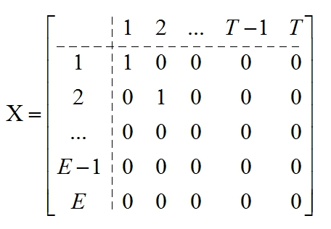

Objective Function

The objective function minimizes the total cost of fuel consumption and additional travel costs incurred from inclement weather as formulated in the cost function C(e,t)=8.48d_{e}+w_{e}(t) shown below. The cost to travel one nautical mile was calculated to be $8.48 since a standard commercial flight consumes 2.569 gallons of jet fuel per mile at a cost of $2.87 per gallon. A conversion of 1.15 nautical miles for every mile was also taken into account. Additional consumption costs that may be incurred from non ideal weather conditions were incorporated in a matrix W. The objective function is given in Equation (1) below.
Minimize 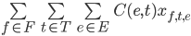 (1)
subject to 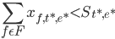 (2)
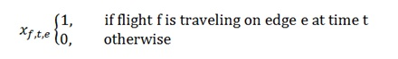
(3)

The constraint as shown in Equation (2) ensures that path congestion stays below a reasonable capacity S. Given the matrix format of X_{f,t,e} sector traffic of any given edge at any given time can be obtained by summing the decision matrices of all flight.

Solving Method

Despite the abstractions and simplifications involved in the problem’s formulation, its complexity is still an obstacle to achieving solutions. One of the difficulties stemmed from the construction of feasible flight routes, specifically a set of edges that actually connect. Rather than procedurally generating a set of optimal paths while simultaneously accounting for sector conflicts, an initial set of independent paths is generated. This ensures that the initial routes are at least connected. Afterwards they are modified to meet sector constraints.

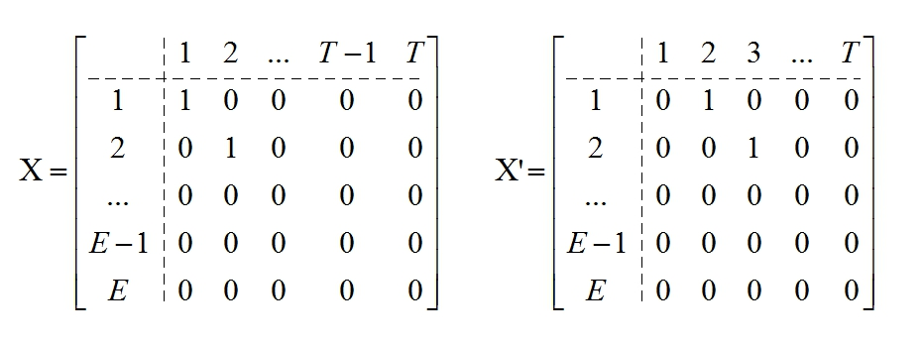
The example above demonstrates a delay of one unit of time applied to a route.

Using Dijkstra’s Algorithm, an optimal path is generated for each flight. In the event that flights have differing departure times, each flight’s decision matrix is offset a number of columns to the right, in relation to the earliest departing flight. The use of matrices allows for sector constraints to be easily tested by summing all of the decision matrices. Each entry in the summed matrix expresses the number of flights using a given edge at a given point in time. Constraint violations are resolved by recalculating optimal paths for each conflicting flight, without considering the node attached to the overpopulated edges at the time resulting in the conflict. The revision that results in the least increase in cost is chosen.

Sector constraints are checked after each revision. If a revision were to result in a new conflict, the next most optimal revision is attempted. In such cases, it is possible that during the adjustment process, revised flight routes create new sector conflicts, which in turn require adjustments that result in the same original constraint violations. In order to mitigate these cyclical corrections, where flights are redirected indefinitely, repeatedly conflicting routes can have their departure times delayed, via a rightward shift of the entries of their decision matrices. In this case, these flights are delayed until the adjustment process of the remaining flights produces no new conflicts, allowing the next conflicting edge to be corrected.

In cases with multiple, cost-inefficient conflicts, the only way a feasible solution may be attained is if some flights are delayed until all conflicting flights have concluded. On a long enough timeline, there is always a feasible set of routes such that no sector conflicts occur. However, when the lengths of time for individual flights are constrained, a set of flights may have no solution, depending how stringent the constraints are. In such cases, this would indicate that the volume of flights is too high for the given constraints. The airline would need to either scale back their operations or revise the policies which dictate sector capacity.

The distances, in nautical miles, between each airport are shown in the chart below as indicated by the positive and zero values. The negative values indicate that an airport is not in an adjacent sector with respect to another airport and thus infeasible to relocate to.
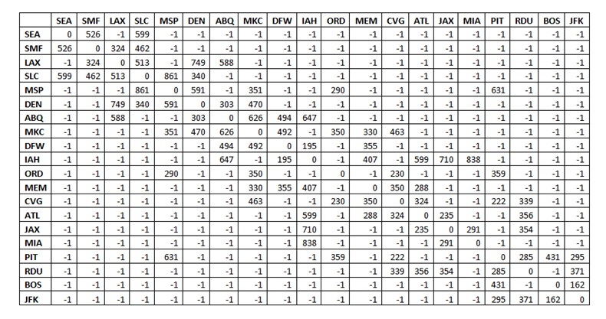
The model divided the United States into sectors based on areas that exhibit similar weather patterns as shown in Figure 1. For simplicity reasons only one airport within each sector was taken into consideration. This produced the node map shown in Figure 2.
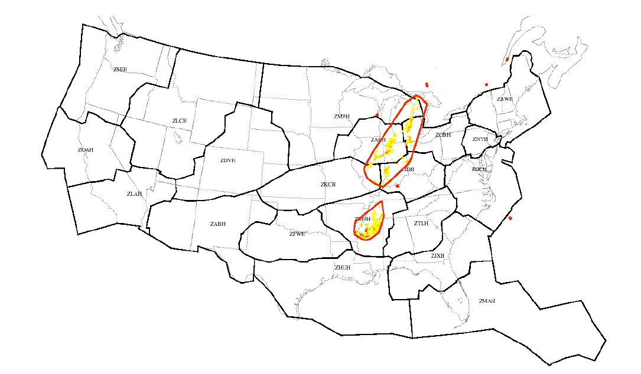
Figure 1: Map of the weather sectors in the United States
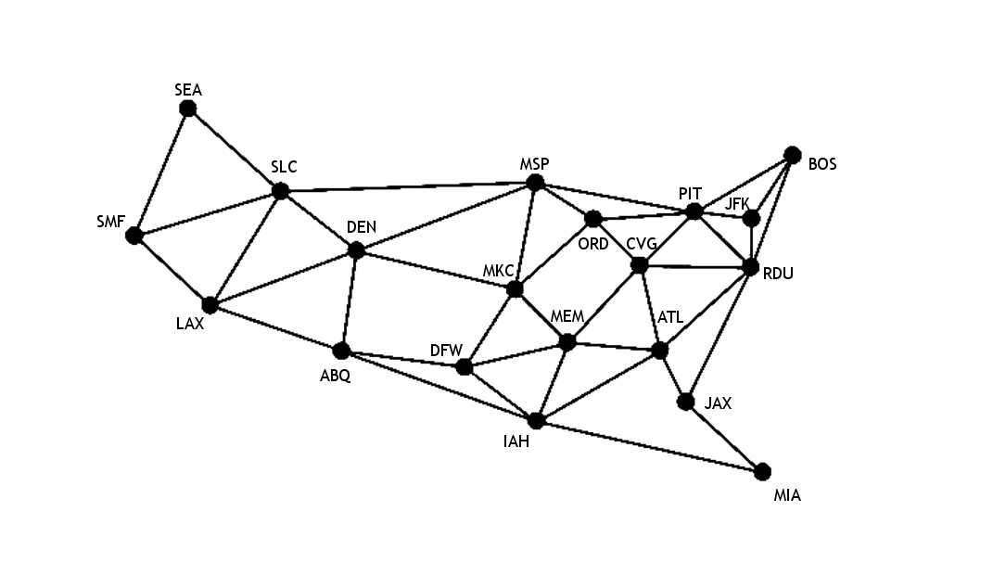
Figure 2: Node Map

Consider the following set of flights, based on an actual timetable of flights from United Airlines. For this scenario, the flights have identical departure times, although as mentioned above, different departure can be easily implemented in separate scenarios. The method for solving the problem remains the same. To limit traffic population, no more than two flights may travel on the same edge at any given point in time.

The code shown in Appendix A can be implemented to solve the shortest path problems in our model to obtain the following results:

Flight | Departure/Arrival | Optimal Route | Total Cost ($)
1 | ATL/ORD | ATL -> CVG -> ORD | 4697.92
2 | ATL/DEN | ATL -> MEM ->MKC ->DEN | 9826.24
3 | PIT/ABQ | PIT -> CVG -> MEM -> DFW -> ABQ | 12050.10
4 | PIT/ATL | PIT -> CVG -> ATL | 4730.08
5 | PIT/ATL | PIT -> CVG -> ATL | 4730.08
6 | LAX/BOS | LAX -> DEN -> MSP -> PIT -> BOS | 22168.96
7 | LAX/DFW | LAX -> ABQ -> DFW | 9275.40
8 | LAX/DFW | LAX -> ABQ -> DFW | 9275.40
9 | CVG/SEA | CVG -> ORD -> MSP -> SLC -> SEA | 16990.40

Summing the decision matrices of the above flights, we observe the following populated edges for the initially calculated routes: flights 3, 4 and 5 at time t=1 on PIT to CVG, flights 7 and 8 at time t=1 on LAX to ABQ, flights 4 and 5 at time t=2 on CVG to ATL and flights 7 and 8 at time t=2 on ABQ to DFW.

At time t=1 on edge PIT to CVG, the sector constraint is violated, with three flights sharing the same edge. By the adjustment process outlined previously, flight 3 will be adjusted by calculating a new route, without visiting CVG at time t=1. By Dijkstra’s Algorithm, the adjusted route is as follows:

3 | PIT/ABQ | PIT -> ORD -> CVG -> MEM -> DFN -> ABQ | 15162.24

This revised route does not create any new sector violations as is the most optimal revision of flight 3.

Alternate Methods

The simplest theoretical approach to obtaining an accurate optimization for this problem is to consider all possible routes that all of the flights can take, and to choose the route mapping that minimizes cost. While simple and accurate, actually implementing this brute force approach is essentially quantitatively impossible, due to the sheer number of possibilities. Specifically, we are looking to consider all possible combinations that X_{f,t,e} can take. Since each of these binary variables has two possible values, to consider all possibilities would require considering 2^(f*e*t) possibilities. Given our map, that means that even if all we wanted to solve was the optimal routing for a single flight, we would have to consider roughly 100,000,000,000,000 possibilities (e=44,t=10). As such, this simple approach is not a feasible one.

In the previous approach, the majority of the possibilities that would be tested represented nonsensical, impossible flight allocations. If we wanted to use a brute force method, we could decrease the computation time and increase the usefulness by limiting our possibilities to feasible paths. To proceed with this approach, we would consider each possible route that each of our flights could take. To make the process possible, we would restrict ourselves to paths where cycles are not allowed, because if we allowed cycles, each of our flights would have an infinite amount of potential routes to take. We would then consider all possible route combinations for all of our flights, and look for the choice that minimizes the cost while not breaking any constraints. While this approach would be far quicker than the previous brute force approach mentioned, it itself is not necessarily very fast or feasible. To generate all possible routes for all of our flights also takes a considerable amount of computational power, as there are potentially hundreds to thousands of paths that are possible for each flight even in our simplified map; when multiplied together to consider all flights, this quickly becomes unworkable. We hypothetically limit our consideration of each flight’s possible routes by considering only the shortest 10 paths or so, but this because the shortest paths likely use many of the same edges, if we have weather constraints that block of certain edges this may not be enough. Furthermore, if were to apply our model to a more realistic scenario that considers millions of sectors, we would find that this method would be every bit as unfeasible as the previous one.

Another alternate approach that is actually is actually workable is to solve each flight’s optimal routing individually and in order based on priority. Priority would be determined by the demand for each of the flights and how busy they are; for example, a flight from New York to Los Angeles would be more important than a flight from Salt Lake City to Atlanta. After solving for each flight, we would then update the map, if necessary, to eliminate edges that become unfeasible due to sector constraints. For example, if we have 8 flights, we first find the optimal routing for the busiest one, update our map to remove overused sectors, find the optimal routing for the second busiest, update the map, etc. This greedy approach is computationally faster than the approach we actually used, and in some cases gives a good enough answer. However, there are problems with this approach. Firstly, because this is a greedy algorithm, the answer that it yields is not guaranteed to be optimal. In particular, our algorithm will prioritize minimizing our most important flights at all costs, so if a set of routing exists that decreases our overall costs by a great amount, but increases the cost of our most important flight by a little, we will non-optimally choose that path. Secondly, this algorithm fails to account for time, and therefore encounters scenarios it cannot solve, even though a solution exists. For example, if we have a destination sector with only one edge connecting to it, and the first n flights cause the edge to be full, this algorithm will be unable to find a way to get to the destination, since it won’t be able to find a way around this roadblock.

Conclusion

Our approach is not perfect but is a good heuristic as it uses a simple procedure to find an estimate to an otherwise tedious problem. Some of the assumptions may not be realistic when applied to actual flights but they make the problem easier to visualize and manipulate as opposed to the other methods mentioned. In most cases, this is enough to prevent enormous loss in terms of cost and time for the airlines and passengers. This model will achieve our goal in raising the on-time flight statistics for most airlines.

The recommended additions to the model would have a more exact optimal solution but is likely not worth the cost of implementing. We advise that this model be used with caution since significant simplifications were made.

Appendix A
Java Code Model Implementation
public class Edge {
private Sector src;
private Sector dest;
private int distance;
private int c;

public Edge(Sector src, Sector dest, int distance)
{
this.src = src;
this.dest = dest;
this.distance = distance;
}
public Edge(Sector src, Sector dest, int distance, int c)
{
this.src = src;
this.dest = dest;
this.distance = distance;
this.c = c;
}

public Sector src()
{
return src;
}

public Sector dest()
{
return dest;
}
public int distance(int t)
{
return distance + c*t;
}
public String toString()
{
return src.getName() + "->" + dest.getName();
}
}

import java.util.Collection;
import java.util.HashMap;
import java.util.HashSet;
import java.util.Iterator;
import java.util.Set;

public class MapGraph
{

HashMap<Sector,HashMap<Sector,Edge>> mapGraph;

public MapGraph()
{
mapGraph = new HashMap<Sector,HashMap<Sector,Edge>>();
}

public MapGraph (Collection<Sector> sectors, Collection<Edge> edges)
{
if(sectors == null || edges == null) throw new NullPointerException();

mapGraph = new HashMap<Sector,HashMap<Sector,Edge>>(sectors.size());

Iterator<Sector> siterator = (Iterator<Sector>)sectors.iterator();
while(siterator.hasNext())
{
Sector tempSector = siterator.next();

if(tempSector == null) throw new NullPointerException();

if(!mapGraph.containsKey(tempSector))
{
HashMap<Sector,Edge> tempHash = new HashMap<Sector,Edge>();
mapGraph.put(tempSector,tempHash);
}
}

Iterator<Edge> iterator = (Iterator<Edge>)edges.iterator();
while(iterator.hasNext())
{
Edge tempEdge = iterator.next();

if(tempEdge == null || tempEdge.src() == null || tempEdge.dest() == null) throw new NullPointerException();
if(tempEdge.src().equals(tempEdge.dest()))throw new IllegalArgumentException("No self-connecting edges"); //Can't have any self-loops

if(!mapGraph.containsKey(tempEdge.src())) //each source vertex maps to a hashmap of destination vertices to the edge in between
{
HashMap<Sector,Edge> tempHash = new HashMap<Sector,Edge>();
tempHash.put(tempEdge.dest(), tempEdge);
mapGraph.put(tempEdge.src(),tempHash);
}

else
{
mapGraph.get(tempEdge.src()).put(tempEdge.dest(), tempEdge);
}
}

}

public MapGraph (MapGraph g)
{
if(g == null) throw new NullPointerException();
Collection<Sector> sectors = g.sectors();
if(sectors == null) throw new NullPointerException();
Iterator<Sector> iterator = (Iterator<Sector>) sectors.iterator();

mapGraph = new HashMap<Sector,HashMap<Sector,Edge>>(sectors.size());

while(iterator.hasNext()) //for each vertex do the following:
{
Sector tempSector = iterator.next();
if(tempSector == null) throw new NullPointerException();

mapGraph.put(tempSector, new HashMap<Sector,Edge>());
Collection<Edge> edges = g.outgoingEdges(tempSector);
Iterator<Edge> iterator1 = (Iterator<Edge>) edges.iterator();
while(iterator1.hasNext()) //iterate through the edges
{
Edge tempEdge = iterator1.next();
if(tempEdge == null||tempEdge.dest() == null) throw new NullPointerException();
if(tempEdge.src().equals(tempEdge.dest()))throw new IllegalArgumentException();
if(!mapGraph.containsKey(tempEdge.src())) //add it to the hashMap in a similar fasion to the prev. constructor
{
HashMap<Sector,Edge> tempHash = new HashMap<Sector,Edge>();
tempHash.put(tempEdge.dest(), tempEdge);
mapGraph.put(tempEdge.src(), tempHash);
}

else
{
mapGraph.get(tempEdge.src()).put(tempEdge.dest(),tempEdge);
}
}
}
}

public boolean removeEdge (Sector src, Sector dest)
{
if(src == null || dest == null) throw new NullPointerException();
if(!mapGraph.containsKey(src) || !mapGraph.containsKey(dest))throw new IllegalArgumentException();
if(!mapGraph.get(src).containsKey(dest))return false;
else
{
mapGraph.get(src).remove(dest);
return true;
}

}

public Set<Sector> sectors ()
{
return mapGraph.keySet();
}

public Edge connected (Sector i, Sector j)
{
if(i == null || j == null) throw new NullPointerException();
if(!mapGraph.containsKey(i) || !mapGraph.containsKey(j))throw new IllegalArgumentException();
if(mapGraph.get(i).containsKey(j))return mapGraph.get(i).get(j);
else return null;
}

public Set<Sector> outgoingNeighbors (Sector sector)
{
if(sector == null) throw new NullPointerException();
if(!mapGraph.containsKey(sector)) throw new IllegalArgumentException();
return (Set<Sector>) mapGraph.get(sector).keySet();
}

public Set<Edge> outgoingEdges (Sector sector)
{
if(sector == null) throw new NullPointerException();
if(!mapGraph.containsKey(sector)) throw new IllegalArgumentException();
Set<Edge> temp = new HashSet<Edge>();
temp.addAll(mapGraph.get(sector).values());
return temp;
}
}

public class Sector {

private String name;
private int capacity;
private int count;

public Sector(){}
public Sector(String myName, int myCap)
{
name=myName;
capacity=myCap;
count=0;
}
public String getName()
{
return name;
}
public int getCapacity()
{
return capacity;
}
public int getCount()
{
return count;
}
}
import java.io.*;
import java.util.*;
public class ORDriver {

/**
* @param args
* @throws IOException
*/
public static void main(String[] args) throws IOException {
File file = new File("map.csv");

BufferedReader bufRdr = new BufferedReader(new FileReader(file));
String line = null;
int row = 0;
int col = 0;
int[][] distances = new int[20][20];
ArrayList<Sector> sectorlist = new ArrayList<Sector>();
ArrayList<Edge> edgelist = new ArrayList<Edge>();
HashMap<Sector, Integer> smap = new HashMap<Sector,Integer>();
HashMap<Integer, Sector> imap = new HashMap<Integer, Sector>();
HashMap<String, Sector> ssmap = new HashMap<String, Sector>();
//read each line of text file
while((line = bufRdr.readLine()) != null)
{
col=0;
StringTokenizer st = new StringTokenizer(line,",");
while (st.hasMoreTokens())
{
if (row==0)
{
Sector s1 = new Sector(st.nextToken(), 3);
sectorlist.add(s1);
smap.put(s1, new Integer(col));
imap.put(new Integer(col), s1);
ssmap.put(s1.getName(), s1);
}
else if (col!=0)
{
String s = st.nextToken();
int dist = Integer.parseInt(s);
if (dist<0)
dist = 1000000; //large
distances[row-1][col-1]=dist;
}
else
{
st.nextToken();
}
col++;
}
row++;
}

//close the file
bufRdr.close();
for(int i = 0; i<20; i++)
{
for(int j=0;j<20;j++)
{
if (distances[i][j] < 1000000 && distances[i][j] >0)
{
Edge e = new Edge(imap.get(i),imap.get(j),distances[i][j]);
edgelist.add(e);
}
}
}
MapGraph map = new MapGraph(sectorlist, edgelist);

Dijkstra dj = new Dijkstra();
Path path = dj.shortestPath(map, ssmap.get("PIT"), ssmap.get("ABQ"));

int i = 0;
for(Edge edge:path.edges())
{
i++;
System.out.println(edge.src().getName() + "-" + edge.dest().getName() + ": " +
edge.distance(i));
}
System.out.println(path.distance());

}

}

Appendix B
Weather Matrix
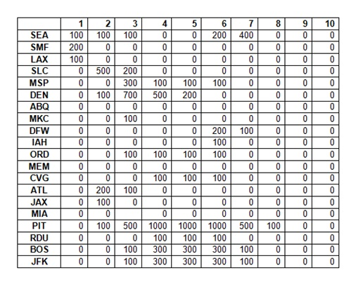

Works Cited

Inter-Airport Distance. (2011). Retrieved from Research and Innovative Technology
Administration: Bureau of Transportation Statistics:
http://www.transtats.bts.gov/distance.asp

Worldwide Timetable. (2011, December). Retrieved from United Airlines:
http://www.uatimetable.com/United.pdf?linkTitle=Worldwide+timetable+PDF

Brookings Metropolitan Policy Program. (2009, March). Appendix 3: 100 Most Traveled Corridors.
Retrieved from Brookings:
http://www.brookings.edu/~/media/Files/rc/reports/2009/1008_air_travel_tomer_puentes/
1008_air_travel_appendix_3.pdf

Mukherjee, A., Sridhar, B., & Grabbe, S. (2010, September 13). Optimizing Flight Departure
Delay and Route Selection Under En Route Convective Weather. Retrieved November
21, 2011, from American Institute of Aeronautics and Astronautics:
http://www.aviationsystemsdivision.arc.nasa.gov/publications/2010/Mukherjee_GNC2010
_final.pdf

