Rent the Runway Optimal Pricing Model

By Group A: Maddie Mesard, Pam Chrissis, Alex Kingsley, Zuojun Gong

Introduction of the Problem Studied
We applied a linear programming model to find an optimal pricing strategy for Rent the Runway. Rent the Runway is a rental service for designer dresses. They display their inventory on their website, where customers can select a dress, a free second size, for either four or eight days. This rental service allows customers to wear dresses to an event, and then send the dress back to Rent the Runway to be cleaned and rented to the next customer. This system comes with a huge cost to the company. Rent the Runway owns its entire inventory. To come up with a pricing strategy, we explored the associated costs, and estimated the demand for each type of dress. Some limitations included not knowing the actual price Rent the Runway pays for their inventory, varying cost of maintenance for each piece, and fluctuating demand.

Data Collection
We collected our data from the Rent the Runway website. We took a sample of dresses and recorded the retail price, rental price, size ranges available, and the number of reviews. From this data, we were able to connect retail price to typical price ranges for rental. We also found that the more sizes that were available for a particular dress, the more expensive the rental. This could be explained by the fact that dresses with fewer size options had a lower demand, and therefore were rented out at a cheaper price. Also, we assumed that the number of reviews of an item was proportional to the demand of that item. Although not everyone who rents a dress reviews it, we assumed that a higher number of reviews and shares on social media reflected a higher demand.
Costs
In addition to collecting data from the website, we were able to speculate about some of the costs associated with general operations of Rent the Runway. We did not take into account the cost of paying employees; we strictly focused on inventory costs.
Rent the Runway owns their inventory, which means they have to buy a huge selection of designer dresses in a full size range. They also have to continuously update their inventory, based on changing fashion trends. Every season, new styles come out and customers will want to be able to rent the latest fashion trends.
In addition to updating their inventory, Rent the Runway also has to pay to maintain their current inventory. Every time a customer rents a dress, it needs to be washed and stored until the next time it is rented. Caring for some of these products can be costly, as many are “dry-clean only”, or require other special care. Rent the Runway also has to account for damages to their dresses. Each item can only be rented a limited amount of times until it is worn out, and can no longer be used.

Demand Model
We collected information of 120 dresses from Rent The Runway website, 30 dresses from each of the categories: Black Tie, Cocktail, Night Out, and Daytime. We have the number of costumer reviews of the dress, the rental price of the dress, the retail price of the dress, the difference between the rental price and retail price of the dress, the rating of the dress from customers, the number of Facebook shares of the dress, and the sizes available of the dress. From Table 1 we can observe the summary distribution of our variables. The mean number of reviews of the dresses is 150.7 and the median is 74.0, with a standard deviation of 224.10 and therefore we conclude that there are potential outliers in our number of reviews. The mean of the rental price of the dresses are $73.1 dollars and the median are $70.00, and the mean of the retail prices are $747.7 and the median are $595.0. The average difference between the rental price and the retail price are $674.6 and the median is $524.0. The average number of Facebook shares is 36.2 and the average sizes available are 9.3. We observed from Figure 1 that all variables are skewed right.

 | Mean | Median | 1st Quantile | 3rd Quantile | SD
Number of Reviews | 150.7 | 74.0 | 38.0 | 165.0 | 224.10
Rental Price of the Dress (in $) | 73.1 | 70.0 | 41.25 | 90.0 | 35.93
Retail Price of the Dress (in $) | 747.7 | 595.0 | 41.25 | 90.00 | 540.27
Rental – Retail Price (in $) | 674.6 | 524.0 | 365.8 | 718.0 | 534.69
Number of Facebook Shares | 36.2 | 20 | 0.0 | 43.0 | 58.00
Sizes Available | 9.3 | 8.0 | 6.0 | 11.0 | 4.73
Table 1: Summary table for Review, Rental, Retail, Retail-Rental, Shares, and Sizes in respective units.
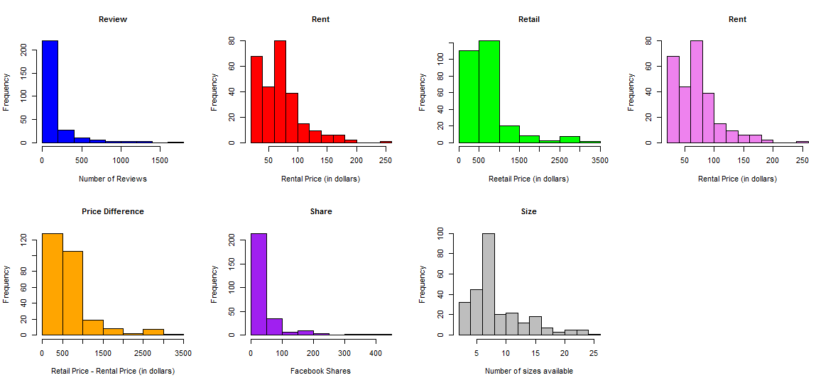
Figure 1: Histograms of the variables
We then wanted determine if a bivariate relationship between the number of reivews, rental price, retial price, ratings, number of shares, and number of sizes available exists. We discovered that there are weak negative corrleation between the number of revies and the rentail and retial price, and there are moderate posotive correlation between the number of Facebook shares and sizes availible and the number of reveiws. There is potential evidence of muticollinearity, since we observed potential relationships between the rental price and retail price, rental prices and sizes availaible. There is also a potential correlation between the number of shares and sizes available, which suggests that there are underlying relationships between the perdicator varaibles, and we will consider the potential interactions between the perdicator variables in the upcoming steps.

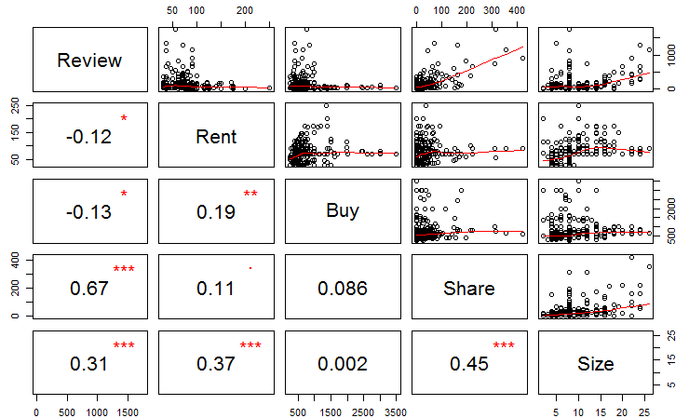
Figure 2: Bivariate Relationship between review, rental price, retail price, number of shares, and sizes available.
We then move on to conditional distribution between types of dresses and its rental, retail price, rating, shares on Facebook and sizes available. We observe that the rental and retail prices of the black-tie dresses have a higher mean than that of the cocktail dresses, and the black-tie dresses have a higher mean sizes available than the cocktail dresses. The average number of shares of the black tie dresses is higher than that of the cocktail dresses. This can possibly be the results of black-dress being more delicate and thus requires a more precise fit and thus black tie dresses usually have more sizes available. The rental prices are higher for black dresses can be a result of its high maintenance and high demand.

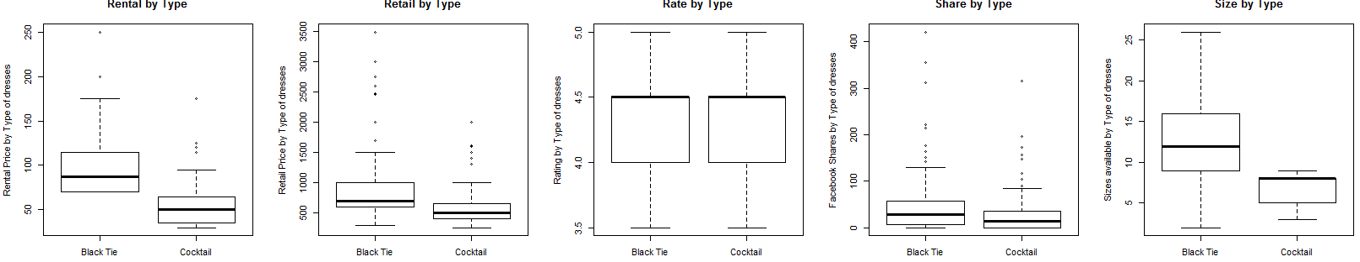
Figure 3: Box-Plot for conditional distributions

We then proceed to determine a demand model based on the influential variables we have observed. In an initial model, we observe a very poor fit and decide that a transformation of the model is necessary to produce a working demand model for our data. We decide on a Box-Cox transformation of Review^0.1 with predictor variables of Rental Price, Retail Price, Type of Dress, Customer Rating, Facebook Shares, and Sizes Available. Our chosen demand model had good residual fitting meeting all model assumptions. The following figures show the chosen transformation and its resulting fit as well as the individual variable residuals compared to their fit. This demand model is then incorporated into our final pricing strategy for the four categories of dresses available at Rent the Runway.
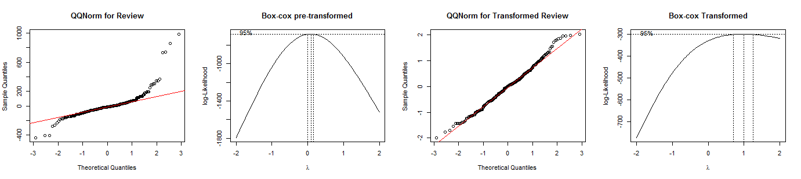

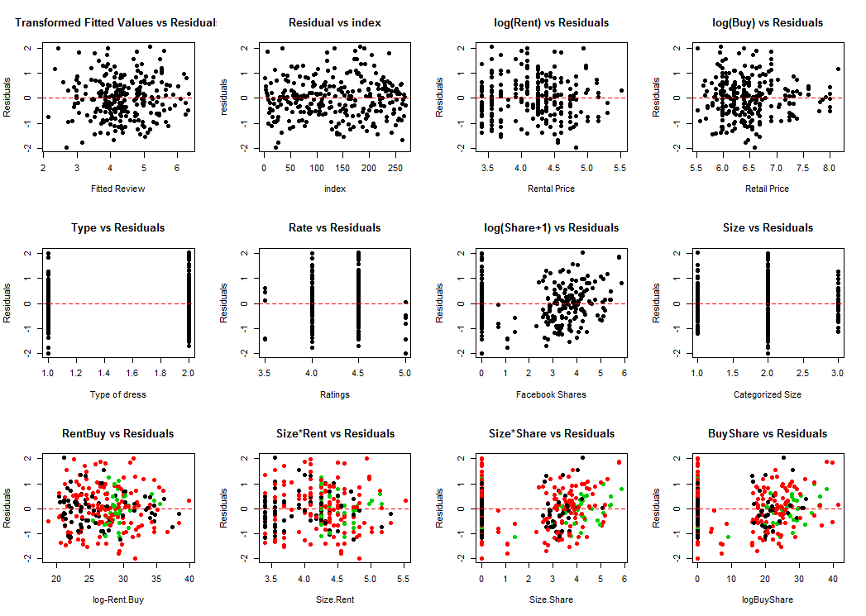
Figure 4: Box-Cox transformation of Review in initial and final models.

Figure 5: Residual vs. Fit plots for final model and variables.
Conclusion
If we had more time, we would have liked to expand our findings to other parts of the fashion industry, such as a new rental section for business attire for college students, which could be a profitable direction for the company. We could split up business attire into the same type of sections as the dresses, such as Dress-Down Friday, Business Casual, Business Formal and Black Tie. We would also have liked to have the actual data of the number of rentals from Rent the Runway, though we felt that using the number of reviews was probably a fairly good estimation. We would ultimately like to share our findings with the company in order to help them maximize profits.

