Printing Optimization

Preeti Farooque
Robyn Lindsey
Joceyln Sikora
Orest Sopka

December 16, 2005
Abstract
The purpose of this study was to determine whether the current placement of CMU printers was optimal, and if not how to redistribute them. In determining this, first the demand at each printer must be determined. To obtain this, the optimal path each student should take to get from a given dorm to a given printer and the optimal path from any given printer to all the academic buildings was determined. Using these numbers, the shortest path algorithm was used to determine the optimal printer students should print at when going from dorm A to academic building B.
The next part of the study involved calculating the demand at each printer based on the number of students expected to go to each academic building. Using the demand an algorithm was used to determine the optimal allocation of printers and the distribution is as follows.
Location | Number of Printers
Location | Original | Reallocated
Baker | 2 | 4
CFA | 2 | 2
Cyert | 2 | 4
Eng/Sci/Wean | 5 | 4
Hunt | 10 | 4
Mellon | 2 | 1
Morewood | 1 | 2
West Wing | 1 | 3
UC | 1 | 2

Introduction
This year Carnegie Mellon University instated a new printing policy for students. It was determined that the school would allocate $40 per semester to the students for printing. Each page printed would cost $.05. One of the benefits of this new program is that now students can print from any location on campus including their personal computer to any one of the multiple printers. This inspired the idea for this project. In order to optimize their time, most students would simply print from their dorm room and pick up the project on the way to class. Therefore, the optimal printer each student should use based on the path from their dorm to the academic building they would most likely be going to must be computed. This was calculated using the shortest path algorithm. Using the optimal printers found and the number of students using the specific paths, the demand at each printer was determined. This was then used to determine if a new allocation of printers was necessary to optimize printing services.

Assumptions
Due to restrictions on the time and data, certain assumptions were made with regards to the model. The first set of assumptions pertains to the shortest path problem:
- The data obtained was only from undergraduate students who lived in campus housing.
- When performing the measurements, it was assumed that students would be taking the shortest path from their residence to the printer, and then traveling the shortest distance from that printer to their classroom.
- When determining which printers that students would be printing to, only public clusters that had instituted the new pay for printing system were included. Private clusters, such as those open only to students of a particular department were exempt for the purposes of this project.
- Only routes that followed normal walking patterns were considered. This consisted of paths along sidewalks and through buildings; however it excluded paths where students can cut across the lawns.
- Certain buildings were grouped as one entity since there is not a significant distance between them. Instances of this grouping occurred in the case of some of the Hill Residences, the fraternities in the quad, as well as Wean and the Engineering Science Library.
There were also multiple assumptions made when finding the demand at each printer:
- This model only addresses print jobs that are being sent from the students’ computer in their dorm room, to a campus printer. Students who may already be in the computer clusters doing work are ignored.
- Students have a majority of their classes in the building that houses their major department, and would consequently print at the optimal printer on their way to this building. For instance, this project assumes that math majors have a significant portion of their classes in Wean since this is where the Mathematical Sciences department is located.
- This year every Carnegie Mellon student was allotted 800 free copies to print. Suppose each student utilizes their entire allotment throughout the course of the 16 weeks of class, 800 ÷ 16 = 50 copies every week,
- Since this model only considers the students who are printing from their home on their way to class, it was assumed that they are only likely to be printing during the weekdays. Assuming an average print job of 5 pages, this would mean each student prints twice a day.
- While measuring the demand at each printer cluster, the printers in Wean and the Engineering Science Library were grouped as one cluster, since they are located in the same building and the path taken by students is the same.

Constraints
There were also a number of constraints included in this model. The first constraint restricted the total number of printers on campus to 26 (the current amount). Even if it was determined that a certain cluster was not using all of its printers or perhaps it needed more, new printers would not be sold or purchased. Rather, redistribution would occur from the current pool of printers. In addition, if a cluster was already in existence, it would keep at least one of its current printers. Lastly, it was determined that Hunt Library was never the optimal place to print, but the model did not take into account the students who are already studying in the library. Therefore, the decision was made to keep four of the existing printers in Hunt. When performing the optimization problem, these four printers were simply removed from the total pool of printers, and reallocation was determined from the remaining 22 printers.

Shortest Path Algorithm
There are 9 printer locations, since the engineering and science library was grouped with Wean, and 26 total printers. Using the 2005 Factbook online (1), there were 27 resident locations and 11 academic buildings that would be included in the model. Using a blown up version of a map of CMU (shown below), the shortest paths from the resident location to the printer and from that printer to the academic building were calculated.
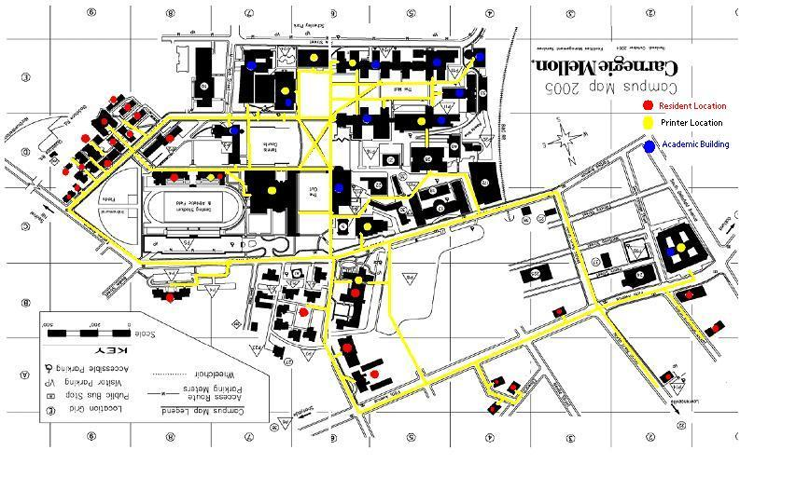

Looking closely at the map, all locations of interest are label. The red stickers denote all resident locations, yellow stickers symbolize a printer location, and blue stickers are academic buildings. Streets and sidewalks highlighted in yellow are the feasible walking paths students were limited too. All measurements taken for this project were done along these lines as well as through buildings.
For taking measurements, a string was used and pinned along the way as it pivoted along the path. To ensure uniform measurements, the string’s starting location was in the center of a red sticker and the paths completion was measured to the center of the yellow printer sticker. The string was then removed, measured in inches, and the distance was converted based on the scale located on the map into feet. This procedure was identical when measuring from printers to academic buildings (Figure 1).
After taking the measurement of all possible paths, the data was then placed into a matrix in excel and the optimal path was determined by using the shortest path algorithm (Figure 2). The general algorithm (1) gives the shortest path (distance) from some node i in level r to the end node. The exact algorithm used is listed below in parts (2-4).
$f_{r}(i)=\underset{j}{\text{min}}\left\{C_{r}(i,j)+f_{r+1}(j)\right\}$ (1)
r = row of nodes
i = starting node
j = destination node

$f_{2}(F)=0$ (2)
$f_{1}(i)=\underset{F}{\text{min}}\left\{C_{1}(i,F)+f_{2}(F)\right\}$ (3)
$f_{0}(S)=\underset{j}{\text{min}}\left\{C_{0}(s,j)+f_{1}(j)\right\}$ (4)

The chart below shows the final optimal results when traveling from each residence to each academic building, highlighting the fact that using the shortest path algorithm, the optimal printer along the path from Spirit to Baker is the Baker cluster printer.

Calculating Demand

After determining the optimal printer for every combination of dorms and academic buildings, the optimal printer configuration could be determined and compared with the existing arrangement. To do this, the demand for each printer needed to be calculated. The students were first broken up by college and then into the various majors within the college and the percentages of students in each of these majors were provided by the Factbook 2005 (1). Following this, the main or two main academic buildings the students of a particular major would visit most frequently was determined (Table 1). This information was determined by the department location for the major (information in the factbook) or by basic knowledge and assumptions. Knowing the percentage of students in each major and the most frequently visited area or two, the percentage of the undergrads that went to each academic building could be computed (Figure 3). Lastly, to determine the demand, the number of students in each resident location was required and again this information was taken from the Factbook 2005 (Figure 4). The final assumption that needed to be made before the demand could be calculated was that the percentage of students attending each academic building (thus the percentage of students in each major) was uniform across all resident locations. For example Figure 3 shows that 20% of the students go to Baker, thus for West Wing, 20% of the residents go to Baker as their main academic building.
To perform the demand calculation, a certain dorm was chosen as well as an academic building. Then the optimal printer for that combination (found on the optimal printer matrix) was found and the demand for that printer was the percentage of students going to the academic building multiplied by the number of students in the resident location. This calculation was performed for each academic building and then for each resident location. The total demand for each printer was the sum of each of these individual demands for the optimal printer. Due to the earlier assumption that each individual prints two jobs per day, to determine the actual demand, the demands found were multiplied by two and each sum of jobs was rounded to the nearest whole number.

Printer Allocation
The final part of this project involved determining the optimal allocation of printers to minimize the total demand on a printer. There were two approaches. The first involved minimizing the sum of the demands per printer. The second involved minimizing the maximum demand per printer. The second was chosen so no one printer had either very small or very large usage compared to others. The optimization problem was as follows:
$\frac{d_{i}}{x_{i}}$
$∀i∈\left\{1\text{.}\text{.}\text{.}8\right\}$ Min max

$x_{i}≥1$ (5)
$\sum_{i=1}^{8}{x_{i}}=\text{22}$

(6)

x_{i} integer

$\frac{x_{i}}{d_{i}}$The first constraint (5) deals with the fact that no printing locations can be completely taken away. One reason for this is that many printers are attached to clusters. The second constraint (6) restricts the number of printers used to only those currently owned by the university. The original total number of printers was 26, but the assumption was made that because Hunt was never an optimal place to print and therefore it would not have a demand, its printer allocation would be placed at the minimum constraint regardless of the objective function. Therefore it was decided that Hunt’s minimum printer allocation would be four and it was taken out of the optimization problem. Since the objective function is non-linear, it must be linearized to apply the known optimization techniques. Therefore, the new optimization equation is:
$∀i∈\left\{1\text{.}\text{.}\text{.}8\right\}$ Max min

Formulated as an integer program:

$ρ≤\frac{x_{i}}{d_{i}}$$ρ$$∀i∈\left\{1\text{.}\text{.}\text{.}8\right\}$$x_{i}≥1$$\sum_{i=1}^{8}{x_{i}}=\text{22}$ Max

x_{i} integer

This solution was then formulated in excel (Figure 5).

Results/ Conclusions
After solving the program above, the reallocation of all 22 printers to their optimal position was found. The chart below on the right shows the original allocation of the printers on campus as well as the demand at each printer. While the chart on the left shows the same figures after our reallocation.

Above it can be seen that after the reallocation, the number of printers is much more balanced with demand. Buildings such as Hunt and Mellon, which originally had considerably less demand per printer than any of the other printer locations, were reduced in the number of printers allocated; while buildings such as Baker and Cyert where demand was much higher were given extra printers (Table 2). If CMU was able to reallocate the printers as suggested, overall, there would be a major improvement in the printing service quality. Specifically, there would be drastic minimizations in the expected wait times at the more popular printing locations.

Work Sited

(1) Carnegie Mellon Factbook 2005 Volume 19 http://www.cmu.edu/planning/
p. 36-37, 117-121, 123, 126,127
Table 1

Table 2
Location | Number of Printers
Location | Original | Reallocated
Baker | 2 | 4
CFA | 2 | 2
Cyert | 2 | 4
Eng/Sci/Wean | 5 | 4
Hunt | 10 | 4
Mellon | 2 | 1
Morewood | 1 | 2
West Wing | 1 | 3
UC | 1 | 2
Figure 1

The picture on this page is an example of all feasible paths from Spirit to Baker with the shortest path going through the Baker cluster printing location. The image on the next page shows some of the optimal paths a student can take. What you may notice in the network diagram on the bottom is that a student can go to two different printers before arriving at the same academic building. This result occurs because there were two equidistant optimal paths.

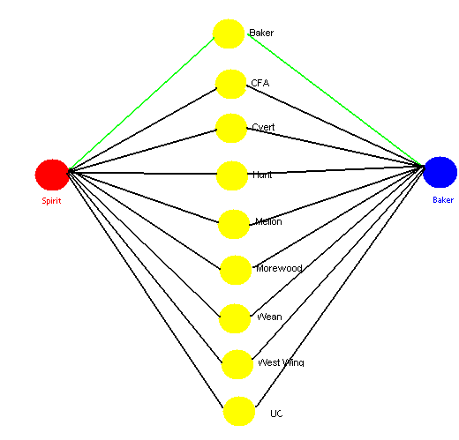

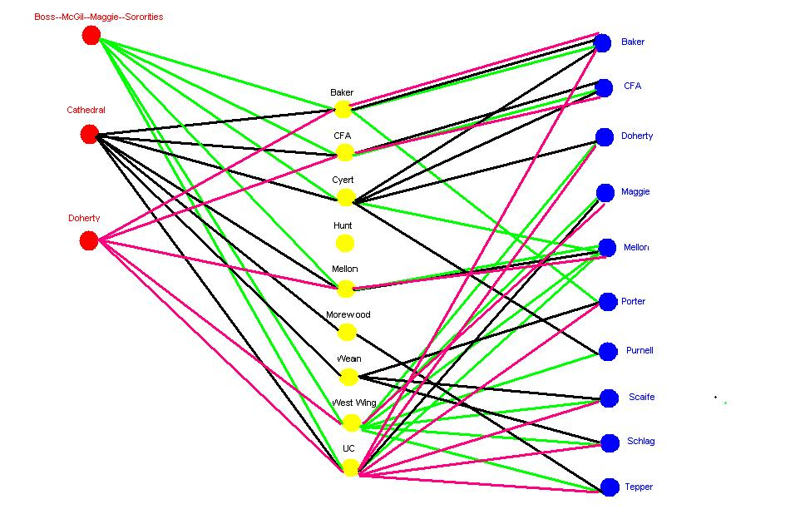

Figure 2

This excerpt from excel shows how the data was arranged and what occurred after the shortest path algorithm was executed. In the example below, the distance is inputted from Spirit to all printers, then from all printers to Baker. When the algorithm is performed, the columns are summed and an optimal path with its distance is given as an output. In this the shortest path from Spirit to Baker is to print in Baker.

Figure 3

Figure 4

Figure 5

See http://www.cmu.edu/computing/clusters

