Rain, Rain Go Away:
An Underground Tunnel Network

Group D
Wilson Chai
Rohan Chatterjee
Kirk Higgins

Operations Research II
Professor Frieze

Table of Contents

- Introduction …………………………….…………..3
- Brief Outline.………………………….……………4
- Problem………………………………….………….5
- Approximations and Assumptions……….………....6
- Procedure and Data Gathering…………….………..7
- Conclusion…………………….………………......14
- Limitations and Further Study….……………..…..16
- Works Cited…………………….………………....17
- Appendix…………………….….………………...18

Introduction

The city of Pittsburgh has been notorious for extremely poor weather. The rains of the fall and spring, and the snow and wind of the winter contribute to this reputation. Too often, students need to endure these hash weather conditions just to get to the academic buildings, to get to lunch from class, and even when traversing class to class. People usually take advantage of the connections between Baker and Porter Hall, and also between Wean Hall, Newell-Simon, and Doherty Hall to avoid the rain and wind. However, this is not enough for most students. Too often students are deterred from going to class due to poor weather. To combat this, we propose a system of underground tunnel. This tunnel network would link academic buildings with each other and also the University Center as well as the Hunt Library, allowing students to freely traverse the campus without having to deal with the weather.
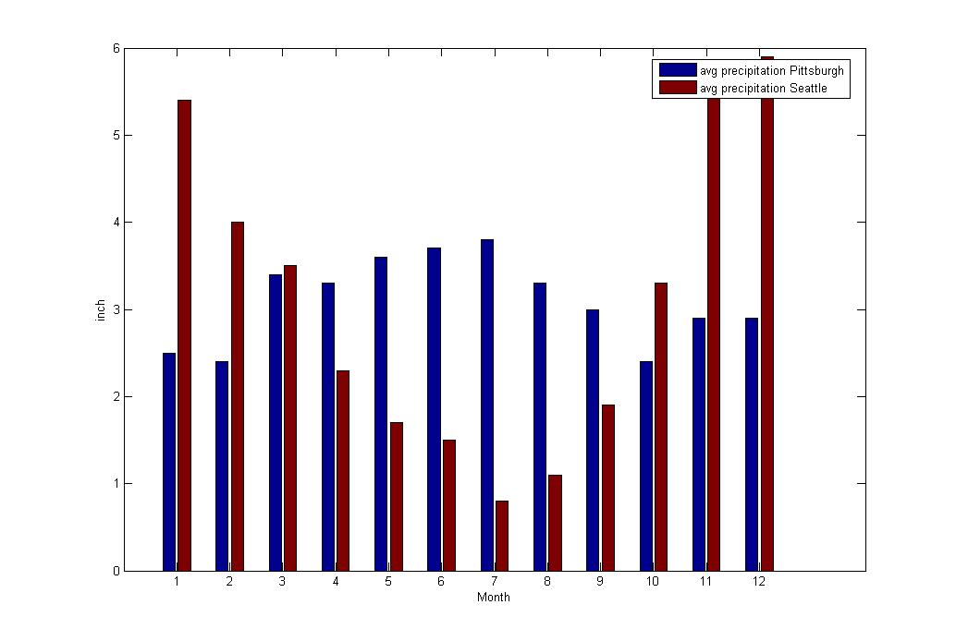
Figure 1: A comparison of average precipitation between Seattle and Pittsburgh

Figure 1, shows a comparison between Pittsburgh and Seattle, which is said to be the rainiest city in the United States, in terms of average precipitation statistics. It shows that Pittsburgh gets a constant amount of rain through out the year while there’s a seasonal trend in Seattle. In fact, the two cities have the same average annual precipitation rate of 3.6 inch. To conclude, we hope that the underground tunnel can shield the students from the hash weather and also increase their incentive of attending classes.

Brief Outline

Here we give a brief outline of our project. Our objective is to produce a tree connecting academic buildings to each other in order to minimize the amount of time the average student will spend trying to get to their destination. To analyze this problem, we must first analyze the class distribution among the academic buildings. Using the schedule of classes and course information online from the HUB, as well as the Carnegie Pulse course scheduler, we can gather information on class sizes and the room usage in the different academic buildings. Using these data, we can come up with an estimate of the number of students in each building on a typical day. We will also analyze potential movement patterns by determining probable schedules for different majors. The second part of this analysis would be to determine the distances between the different buildings on campus. All academic buildings, Hunt Library, and the University Center will be considered in this discussion. For simplicity, we assumed that the tunnel would connect the main exiting entrances of the academic buildings. This data set would contain all possible pathways organized in a matrix form. Finally, using the class distribution, traffic patterns and distance analysis, we would then build a minimal spanning tree that connects all the academic buildings. This network would allow students to freely go between classes and to the University Center or Hunt Library without exposing themselves in any open area.

Problem

The objective of this project is to produce a minimal spanning tree of tunnels that will minimize the amount of time the average undergraduate student will take to get their respective destination.
The problem consists of several components.
- We need to discover and define the general population of students that attend classes within each building.
- We need to find the length between each building
iii. We need to determine the traveling patterns of student who attend classes within each building.

We will incorporate all this information to produce a ratio of the flow of students between buildings over the distance between each building.

We are assuming each student will travel to each destination at the same speed.

(Speed) * (Population) = (Distance)* (Population) = Population
(Distance) (Time) (Distance) Time

Thus, speed is inconsequential factor for this ratio.

This number will be the weight of each edge between buildings.

This inverse of this ratio can then be used to describe the average amount of time per student.

Thus, maximizing this ratio is analogous to minimizing the average time per student.
Another thing to note is that our minimal spanning tree gives priority to paths between academic buildings over paths between from an academic building to the University Center or to Hunt Library.

Approximations and Assumptions

There were many assumptions made during the data collection process.

The topology of Pittsburgh would make calculations for tunnel building very tedious and difficult. Thus, we treated the campus as a single plane, ignoring any issues in elevation difference between the respective buildings in determining the distance between the buildings.

Factoring in time would have made the calculation process long and tiresome, since the data would have to be collected class by class at every time of the day. To approximate the flow between buildings, we determined an average building capacity, taking into account the total number of classes in each building over the course of the day, and the size of the classes in each room. This factored in time indirectly, but allowed for simpler calculations.

Often, students, when walking from their current starting point to another building, would pass through a third building along the way. For example, a student traveling to Hunt Library from Scaife Hall would often walk inside Baker/Porter Hall. To simplify calculations, this intermediary traffic was ignored in calculations, as it was assumed that students, given access to underground tunnels, would take a direct path.

Since our algorithm will take into account the number of students traveling between buildings and the length between buildings, this would imply that we would be looking to minimize the cost of constructing tunnels. To simplify calculations, we will assume that the value of the edges will factor in the maximum flow and shortest path between buildings, and thus the minimal spanning tree would yield the optimal solution.

Procedure and Data Gathering

To determine which tunnels would be the most important to build, we gathered our data in a three step process.

The buildings that were considered in this study were Doherty Hall, Wean Hall, Newell-Simon, Baker Hall, Porter Hall, Margaret Morrison, CFA, Hamerschlag Hall, Tepper, Scaife Hall, and the Purnell Center.

Below is a connected graph connecting every academic building on campus, and connecting every building to the University Center and Hunt Library, two popular on-campus destinations for use during the day.
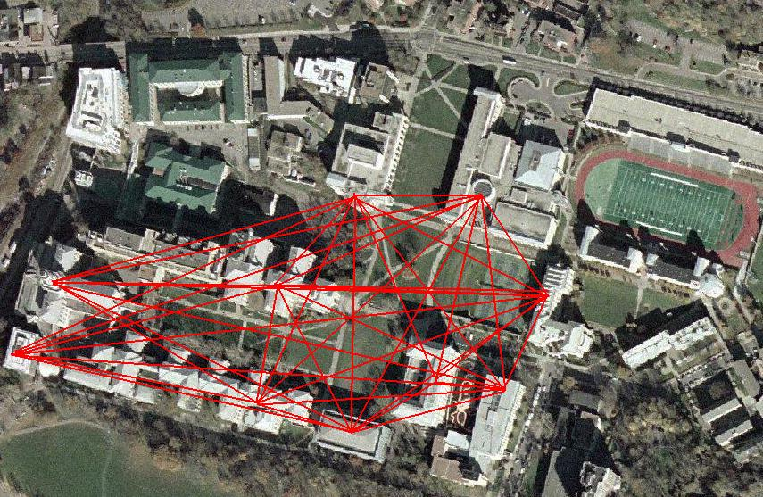

First, we built a table of the distribution of departments through the Carnegie Mellon campus. We looked at every undergraduate department, including 100-400 level classes, and noted every instance of at least one class in any academic building. For example, if there were one 100-level biology class in Doherty Hall, we would note it in our table. However, we would not count if there were more classes in Doherty Hall beyond that. We also considered an academic building an enclosed structure where students need not leave go outside. Thus, Doherty Hall and Wean Hall were considered as one entity, as well as Baker Hall and Porter Hall. We used the HUB’s “Schedule of Classes” page to find our data. Below is a sample of this data set:
Fall 2006 Class Distribution By Department/Building
Major | Level | DH/WEH/NS | BH/PH | MM | CFA | HH | GSIA | ScH | Purnell
Count | N/A | 67 | 69 | 16 | 24 | 17 | 5 | 34 | 4
Architecture | 100 |  | 1 | 1
Architecture | 200 | 1 |  | 1
Architecture | 300 |  |  | 1 | 1
Architecture | 400 |  |  | 1 | 1
Architecture | 500 |  |  | 1 | 1
Art | 100 |  |  | 1 | 1
Art | 200 |  |  |  | 1
Art | 300 | 1 |  | 1 | 1
Art | 400 | 1 | 1 |  | 1

After this data set was built, a table was compiled of the total connections between buildings, noted by department and class level. This table estimated the amount students would travel between buildings, assuming that, for example, 100 level classes would be for freshman in each department, and 200 level classes would be for sophomores. By knowing what buildings would be used by what departments in different academic years, we gained an idea of between which buildings students would go most often.
It was after this data compilation that we decided to remove the Purnell Center from our analysis. It was determined that this building was used exclusively by drama students, and that the drama department did not have classes in other buildings. Thus, there would be no need to connect the Purnell Center to other academic buildings on campus, according to our study.

This resulting table follows:

Possible Paths | Total Usage
DH/WEH/NS to BH/PH | 50
DH/WEH/NS to ScH | 28
BH/PH to ScH | 28
BH/PH to HH | 15
BH/PH to CFA | 14
DH/WEH/NS to HH | 13
DH/WEH/NS to CFA | 12
HH to ScH | 10
MM to CFA | 9
CFA to ScH | 6
BH/PH to GSIA | 5
DH/WEH/NS to MM | 4
CFA to HH | 4
DH/WEH/NS to GSIA | 3
BH/PH to MM | 3
GSIA to ScH | 3
CFA to GSIA | 1
HH to GSIA | 1
MM to HH | 0
MM to GSIA | 0
MM to ScH | 0

The second major part of the data collection was the distances between the buildings themselves. One major pitfall in this calculation was the lack of direct open paths between many of the buildings. While walking directly between Baker Hall and Doherty Hall was feasible, walking between Scaife Hall and CFA was far more complicated. For simplicity, we estimated these distances using data from actual walking between the buildings. We used one of our group members, Wilson, to walk from each building to each other building, and compiled the data on every building. The total number of Wilson’s footsteps between the buildings was used as the standard measurement of the distance between buildings, as we assumed Wilson to be an average student.

The resulting data follows:

Distances Between Buildings (Footsteps of Wilson)
 | DH/WEH/NS | BH/PH | MM | CFA | HH | GSIA | ScH | Purnell | UC | Hunt
DH/WEH/NS | 0
BH/PH | 155 | 0
MM | 620 | 1000 | 0
CFA | 420 | 460 | 450 | 0
HH | 155 | 155 | 1450 | 1125 | 0
GSIA | 570 | 950 | 205 | 400 | 1400 | 0
ScH | 305 | 305 | 1625 | 1275 | 150 | 1550 | 0
Purnell | 350 | 700 | 600 | 575 | 1075 | 810 | 1225 | 0
UC | 320 | 870 | 200 | 600 | 1255 | 405 | 1550 | 350 | 0
Hunt | 470 | 130 | 840 | 350 | 285 | 800 | 435 | 735 | 910 | 0

The third part of our data collection was an analysis of the capacity of every academic building on campus. To do this, we looked at every single academic room in each building. Using enrollment sizes of the classes as an estimate of each room’s capacity, and the number of classes held in the room during the semester, we determined the average capacity of each building. This would serve as an estimate of the number of students in a building at any given time over the course of the semester. To gather this data, we used the HUB’s “Course Information Online” page and the TC Pulse to determine the quantity of courses in each academic building.

A sample of this data set follows:
Scaife rm# | Class capacity | total # of classes
125 | 95 | 16
208 | 30 | 13
212 | 20 | 9
214 | 45 | 16
219 | 45 | 12
220 | 35 | 19
222 | 35 | 19
 | average capacity | 45

Using this building data, we compiled the average capacity of every building on campus, as well as the total capacity of each building for the semester. Below is this table:

Building | Avg. Cap.
HH | 62.90
DH/WEH/NS | 54.42
GSIA | 52.90
ScH | 45.00
BH/PH | 38.10
MM | 37.19
Purnell | 26.74
CFA | 17.60
Building | Total Cap
DH/WEH/NS | 23837
BH/PH | 20618
GSIA | 9363
MM | 5802
ScH | 4680
Purnell | 4332
CFA | 2834
HH | 2516

We used this data to calculate our edge values. The edge value was calculated using this formula:
Class Distribution*Building Density
Distances Between Buildings

This ratio of the flow between buildings to the distance between buildings determines the value of connection between them.

Building Density was calculated by adding the average capacity of each node for a respective edge.

Using this formula, we calculated the edge values, forming the table that follows:

Edges | Values
DH/WEH/NS to BH/PH | 29.84
DH/WEH/NS to HH | 9.84
BH/PH to HH | 9.77
DH/WEH/NS to ScH | 9.13
BH/PH to ScH | 7.63
HH to ScH | 7.19
DH/WEH/NS to CFA | 2.06
BH/PH to CFA | 1.70
MM to CFA | 1.10
DH/WEH/NS to MM | 0.59
DH/WEH/NS to GSIA | 0.56
BH/PH to GSIA | 0.48
CFA to ScH | 0.29
CFA to HH | 0.29
BH/PH to MM | 0.23
GSIA to ScH | 0.19
CFA to GSIA | 0.18
HH to GSIA | 0.08
MM to HH | 0.00
MM to GSIA | 0.00
MM to ScH | 0.00

Using this table, we would then pick the edges for the minimal spanning tree for the academic buildings.

To determine the buildings that would be connected to Hunt Library and the University Center, we modified the formula for these respective edges:
Building Capacity (Students)
Distance to Hunt/UC
We used the total capacity for each building as the building capacity, assuming that students would use these facilities at any point over the course of a day. This yielded the following tables:
Buildings | Hunt Value |  | Buildings | UC Value
BH/PH | 158.60 |  | DH/WEH/NS | 74.49
DH/WEH/NS | 50.72 |  | BH/PH | 23.70
GSIA | 11.15 |  | Purnell | 12.38
ScH | 10.76 |  | GSIA | 11.70
HH | 8.83 |  | ScH | 10.76
CFA | 8.10 |  | HH | 8.83
MM | 6.91 |  | CFA | 8.10
Purnell | 5.89 |  | MM | 6.91

Conclusion

As stated in the problem, the inverse of the value ratio we found can be used to describe the average time per student traveling through a respective path. Finding the maximum ratio is analogous to finding the minimum time per student to adjust the algorithm below.
We used Kruskal’s algorithm to produce the Minimal Spanning Tree.
We treated each of the academic clustered buildings as vertices. Since there are seven nodes, Kruskal’s algorithm requires the minimal spanning tree to use six edges. We had already sorted the edges in descending value order.

- We create an edgeless graph with the seven nodes.
- We then initiate the algorithm by choosing the edge with the largest value and adding it to our graph.
- We then add the next edge that does not produce a cycle.
- We repeat Step C until six edges have been added.

We then add two more vertices to our present graph (Hunt Library and University Center). We simply add the largest edge connecting Hunt Library to any one of the academic clustered buildings. We then add the largest edge connecting the University Center to any one of the academic buildings.

The Minimal Spanning Tree
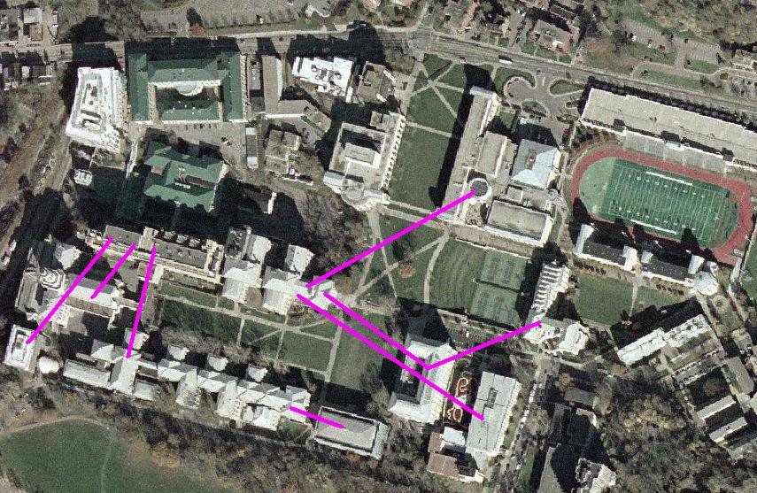

The Minimal Spanning Tree consists of the edges

1) Baker/Porter to Doherty/Newell Simon/Wean
2) Hamerschlag to Doherty Hall/Newell Simon/Wean
3) Scaife to Doherty/Newell Simon/Wean
4) Doherty/New Simon/Wean to Center for Fine Arts
5) Center for Fine Arts to Margaret Morrison Hall
6) Doherty/Wean/Newell Simon to Tepper School of Business
7) Baker/Porter Hall to Hunt Library
8) Doherty/New Simon/Wean Hall to University Center

Limitations & Potential Extensions of Study

The study that was built was limited to academic buildings on campus. One potential expansion of the study would be to include dorm buildings as well. This would theoretically allow students to walk between their rooms and campus, as well as between classes without being exposed to the elements. However, this calculation, using our current model would be far too difficult, since the distribution of majors in on-campus housing is unknown, and would be nearly impossible to determine.

To add value to the distance calculation, we could take into account elevation differences between buildings as a factor. Again, this would not be easy to calculate given the current model.

One important factor that was ignored was potential intermediary traffic between buildings, where students would use a third academic building when in transit from one to another. The example presented earlier, where a student walks between Scaife Hall and Hunt Library, walking through Baker Hall in transit, fits this model. An expansion of the model would take into account for this traffic. However, this could not be calculated using a minimum spanning tree, and perhaps could be solved using a different algorithm, such as max flow.

In this study, the goal was to minimize the number of tunnels constructed. A future expansion of this study could determine a potential cost of each tunnel, based on the ratio of width (based on the building capacities/class distribution) to length (walking distance between buildings), and their respective costs according to construction data. We would determine whether it would be cheaper to build long, narrow tunnels, or shorter, wider tunnels. However, this data could not be collected under the assumption of the model, and would require research into tunnel costs that would go beyond the current scope of the project. However, with limited assumptions, this could be achieved using the current model.

Works Cited

- Course Information Online. Carnegie Mellon University HUB.
https://acis.as.cmu.edu/cio/
- Course Scheduler. The Carnegie Pulse www.tcpulse.com
- Walker, Russ. Introduction to Mathematical Programming.

Shrink wrapped version, 2005

Appendix

Fall 2006 Class Distribution By Department/Building
Major | Level | DH/WEH/NS | BH/PH | MM | CFA | HH | GSIA | ScH | Purnell
Count | N/A | 67 | 69 | 16 | 24 | 17 | 5 | 34 | 4
Architecture | 100 |  | 1 | 1
Architecture | 200 | 1 |  | 1
Architecture | 300 |  |  | 1 | 1
Architecture | 400 |  |  | 1 | 1
Architecture | 500 |  |  | 1 | 1
Art | 100 |  |  | 1 | 1
Art | 200 |  |  |  | 1
Art | 300 | 1 |  | 1 | 1
Art | 400 | 1 | 1 |  | 1
Biology | 100 | 1 | 1 |  | 1
Biology | 200 | 1 | 1
Biology | 300 | 1 | 1
Biology | 400 | 1 | 1
Biomed | 100 | 1 | 1
Biomed | 200 |  | 1
Biomed | 300 | 1 |  | 1
Biomed | 400 | 1
Business | 100 | 1 | 1 |  |  |  | 1
Business | 200 |  | 1 |  |  | 1
Business | 300 |  | 1 |  | 1 | 1 | 1 | 1
Business | 400 | 1 | 1
Chem-E | 100 | 1 |  |  |  |  |  | 1
Chem-E | 200 | 1
Chem-E | 300 | 1 |  |  |  |  |  | 1
Chem-E | 400 | 1 | 1
Chemistry | 100 | 1
Chemistry | 200 | 1 | 1 |  |  |  |  | 1
Chemistry | 300 | 1 | 1
Chemistry | 400 | 1
Civ-E | 100 | 1
Civ-E | 200 | 1 | 1
Civ-E | 300 |  | 1 |  |  |  |  | 1
Civ-E | 400 |  | 1
Comp. Sci. | 100 | 1 | 1
Comp. Sci. | 200 | 1 | 1 |  |  |  |  | 1
Comp. Sci. | 300 | 1 | 1 |  |  | 1 |  | 1
Comp. Sci. | 400 | 1 | 1 |  |  |  |  | 1
Design | 100 |  |  | 1
Design | 200 |  | 1 | 1
Design | 300 |  |  | 1
Design | 400 |  | 1 | 1
Drama | 100 |  |  |  |  |  |  |  | 1
Drama | 200 |  |  |  |  |  |  |  | 1
Drama | 300 |  |  |  |  |  |  |  | 1
Drama | 400 |  |  |  |  |  |  |  | 1
Economics | 100 | 1 |  |  |  |  |  | 1
Economics | 200 | 1 | 1 |  |  |  | 1 | 1
Economics | 300 | 1 | 1 |  |  |  | 1 | 1
Economics | 400 |  | 1 |  |  |  | 1
ECE | 100 | 1 | 1 |  |  | 1
ECE | 200 | 1 | 1 |  |  | 1 |  | 1
ECE | 300 | 1 | 1 |  |  | 1 |  | 1
ECE | 400 |  | 1 |  |  | 1 |  | 1
English | 100 | 1 | 1 |  | 1 | 1 |  | 1
English | 200 | 1 | 1 |  | 1 |  |  | 1
English | 300 |  | 1 |  | 1
English | 400 |  | 1 |  | 1 | 1
History | 100 | 1 | 1 |  |  |  |  | 1
History | 200 | 1 | 1 |  |  |  |  | 1
History | 300 | 1 | 1
History | 400 |  | 1 |  | 1 |  |  | 1
Mat. Sci. | 100 | 1
Mat. Sci. | 200 | 1 | 1 |  |  | 1 |  | 1
Mat. Sci. | 300 | 1 | 1
Mat. Sci. | 400 | 1
Math | 100 | 1 | 1 |  | 1 |  |  | 1
Math | 200 | 1 | 1 |  | 1 | 1 |  | 1
Math | 300 | 1 | 1 |  |  | 1 |  | 1
Math | 400 |  | 1 |  |  |  |  | 1
Mech. Eng. | 100 | 1 |  |  |  |  |  | 1
Mech. Eng. | 200 | 1 | 1 |  |  |  |  | 1
Mech. Eng. | 300 | 1 | 1 |  |  |  |  | 1
Mech. Eng. | 400 | 1 |  |  |  | 1 |  | 1
Modern La. | 100 | 1 | 1 |  | 1
Modern La. | 200 | 1 | 1 |  |  |  |  | 1
Modern La. | 300 | 1 | 1 |  | 1
Modern La. | 400 | 1 | 1
Music | 100 | 1 |  | 1 | 1
Music | 200 |  |  | 1 | 1
Music | 300 |  |  | 1 | 1
Music | 400 |  |  | 1 | 1
Philosophy | 100 | 1 | 1 |  | 1
Philosophy | 200 | 1 | 1 |  |  |  |  | 1
Philosophy | 300 |  | 1
Philosophy | 400 | 1 | 1
Physics | 100 | 1 | 1 |  | 1
Physics | 200 | 1 | 1 |  |  | 1
Physics | 300 | 1 | 1 |  |  | 1
Physics | 400 | 1 |  |  |  | 1
Psychology | 100 | 1 | 1
Psychology | 200 |  | 1
Psychology | 300 |  | 1
Psychology | 400 | 1 | 1
SDS | 100 | 1 | 1 |  |  |  |  | 1
SDS | 200 | 1 | 1
SDS | 300 | 1 | 1 |  |  |  |  | 1
SDS | 400 |  | 1
Statistics | 100 |  |  |  |  |  |  | 1
Statistics | 200 | 1 | 1 |  |  | 1
Statistics | 300 |  | 1
Statistics | 400 | 1 | 1 |  |  |  |  | 1

Possible Paths | Total Usage
DH/WEH/NS to BH/PH | 50
DH/WEH/NS to ScH | 28
BH/PH to ScH | 28
BH/PH to HH | 15
BH/PH to CFA | 14
DH/WEH/NS to HH | 13
DH/WEH/NS to CFA | 12
HH to ScH | 10
MM to CFA | 9
CFA to ScH | 6
BH/PH to GSIA | 5
DH/WEH/NS to MM | 4
CFA to HH | 4
DH/WEH/NS to GSIA | 3
BH/PH to MM | 3
GSIA to ScH | 3
CFA to GSIA | 1
HH to GSIA | 1
MM to HH | 0
MM to GSIA | 0
MM to ScH | 0

Room Sizes
 | Capacity of Rooms | Total Courses
College of Fine Arts |  | 161
M160 | 12 | 19
A2 | 14 | 16
M157 | 20 | 15
102 | 20 | 14
ACH | 20 | 14
211 | 30 | 14
206A | 24 | 11
303 | 20 | 11
212 | 16 | 10
A6 | 6 | 6
Kresge | 20 | 5
213 | 12 | 4
152 | 6 | 2
310 | 10 | 2
323 | 12 | 2
318 | 20 | 2
4TH | 12 | 2
317 | 10 | 2
A4 | 12 | 1
200 | 15 | 1
304 | 12 | 1
220 | 5 | 1
308-9 | 20 | 1
SHOP | 15 | 1
154 | 10 | 1
214 | 5 | 1
313 | 20 | 1
A1 | 20 | 1
 | Average Capacity | 17.60
MM |  | 156
103 | 80 | 29
119 | 14 | 21
A14 | 110 | 15
227 | 12 | 13
A11 | 18 | 13
116 | 5 | 12
121 | 25 | 9
127 | 20 | 8
119A | 10 | 8
B3 | 25 | 4
B16 | 12 | 3
115 | 25 | 3
3RDFL | 5 | 3
211 | 30 | 2
203 | 80 | 2
B2 | 10 | 2
212 | 28 | 2
111 | 25 | 2
415IW | 8 | 2
403 | 15 | 1
17D | 10 | 1
407 | 10 | 1
 | Average Capacity | 37.19
Porter Hall |  | 300
225B | 30 | 20
A19 | 35 | 20
A21 | 35 | 19
A22 | 30 | 18
7F | 30 | 17
226A | 35 | 17
226B | 35 | 17
125B | 30 | 16
A19C | 20 | 16
A20 | 35 | 15
125C | 70 | 14
A18A | 50 | 14
226C | 35 | 13
A18B | 50 | 13
126A | 30 | 12
A18C | 50 | 12
100 | 234 | 11
A19D | 20 | 11
A20A | 10 | 6
107E | 45 | 5
A21A | 10 | 5
27 | 12 | 4
A19A | 10 | 4
223D | 25 | 1
 | Average Capacity | 41.72
Wean Hall |  | 209
5403 | 65 | 19
8427 | 35 | 18
5302 | 40 | 15
5312 | 30 | 15
5320 | 30 | 14
7500 | 152 | 14
5310 | 30 | 13
6423 | 35 | 13
5328 | 20 | 12
4615A | 10 | 11
5316 | 20 | 11
4623 | 40 | 10
5304 | 20 | 9
7316 | 25 | 8
5409 | 45 | 7
5202-4 | 30 | 4
5419A | 25 | 3
5419B | 25 | 3
5419D | 25 | 3
5419C | 25 | 1
5324 | 30 | 1
5419AB | 45 | 1
2318 | 10 | 1
8220 | 20 | 1
7220 | 25 | 1
5419CD | 45 | 1
 | Average Capacity | 40.76
Baker Hall |  | 235
237B | 35 | 19
A53 | 50 | 18
255A | 28 | 18
235B | 35 | 17
136A | 35 | 17
336B | 18 | 17
231A | 16 | 16
231B | 20 | 16
235A | 35 | 15
A51 | 144 | 15
340A | 19 | 13
150 | 27 | 9
A54 | 15 | 8
340J | 15 | 7
140F | 25 | 6
140C | 19 | 5
154A | 10 | 5
255B | 35 | 4
246A | 10 | 4
140E | 10 | 3
232Q | 20 | 2
342D | 15 | 1
 | Average Capacity | 34.47
Doherty |  | 225
1212 | 35 | 23
1217 | 35 | 19
2105 | 35 | 18
2302 | 100 | 18
1117 | 30 | 16
1211 | 35 | 16
2122 | 35 | 14
1112 | 99 | 13
2210 | 278 | 13
2315 | 258 | 12
A310 | 60 | 12
A301D | 25 | 6
1209 | 30 | 5
2303 | 30 | 4
1302 | 50 | 3
3200 | 20 | 3
A200 | 25 | 3
B304 | 15 | 3
C316 | 12 | 3
A331 | 25 | 2
B302 | 12 | 2
C300 | 14 | 2
D200 | 14 | 2
1102 | 20 | 1
3207 | 15 | 1
3302 | 43 | 1
A100 | 25 | 1
A311 | 15 | 1
A324 | 25 | 1
A325 | 25 | 1
B301 | 14 | 1
B305 | 12 | 1
C202 | 14 | 1
C301 | 14 | 1
C308 | 14 | 1
MA341 | 20 | 1
 | Average Capacity | 68.08
Purnell Center |  | 162
103 | 20 | 14
305 | 15 | 13
231 | 10 | 13
107 | 65 | 12
307 | 25 | 12
A41 | 20 | 11
211 | 25 | 8
306 | 25 | 8
A16 | 20 | 8
184 | 100 | 8
321 | 20 | 8
313 | 20 | 7
318 | 20 | 7
324 | 12 | 6
308 | 20 | 5
314 | 20 | 5
A35 | 20 | 5
304 | 30 | 4
209 | 15 | 4
210 | 20 | 2
A19 | 15 | 1
114 | 20 | 1
 | Average Capacity | 26.74
Scaife |  | 104
125 | 95 | 16
208 | 30 | 13
212 | 20 | 9
214 | 45 | 16
219 | 45 | 12
220 | 35 | 19
222 | 35 | 19
 | Average Capacity | 45.00
GSIA |  | 177
145 | 50 | 27
153 | 75 | 20
146 | 50 | 19
152 | 80 | 18
CP | 50 | 16
SIM | 75 | 13
151 | 50 | 13
318 | 20 | 12
261 | 10 | 12
240 | 25 | 8
242 | 25 | 7
MN | 140 | 6
227 | 7 | 4
229 | 45 | 1
259 | 50 | 1
 | Average Capacity | 52.90
HH |  | 40
B131 | 78 | 14
B103 | 78 | 12
B301 | 55 | 4
A104 | 26 | 3
1305 | 26 | 2
A101 | 26 | 2
1303 | 26 | 1
1107 | 25 | 1
B134 | 35 | 1
 | Average Capacity | 62.9

Distances Between Buildings (Footsteps of Wilson)
 | DH/WEH/NS | BH/PH | MM | CFA | HH | GSIA | ScH | Purnell | UC | Hunt
DH/WEH/NS | 0
BH/PH | 155 | 0
MM | 620 | 1000 | 0
CFA | 420 | 460 | 450 | 0
HH | 155 | 155 | 1450 | 1125 | 0
GSIA | 570 | 950 | 205 | 400 | 1400 | 0
ScH | 305 | 305 | 1625 | 1275 | 150 | 1550 | 0
Purnell | 350 | 700 | 600 | 575 | 1075 | 810 | 1225 | 0
UC | 320 | 870 | 200 | 600 | 1255 | 405 | 1550 | 350 | 0
Hunt | 470 | 130 | 840 | 350 | 285 | 800 | 435 | 735 | 910 | 0

Edges | Values |  | Buildings | Hunt Value |  | Buildings | UC Value
DH/WEH/NS to BH/PH | 29.84 |  | BH/PH | 158.60 |  | DH/WEH/NS | 74.49
DH/WEH/NS to HH | 9.84 |  | DH/WEH/NS | 50.72 |  | BH/PH | 23.70
BH/PH to HH | 9.77 |  | GSIA | 11.15 |  | Purnell | 12.38
DH/WEH/NS to ScH | 9.13 |  | ScH | 10.76 |  | GSIA | 11.70
BH/PH to ScH | 7.63 |  | HH | 8.83 |  | ScH | 10.76
HH to ScH | 7.19 |  | CFA | 8.10 |  | HH | 8.83
DH/WEH/NS to CFA | 2.06 |  | MM | 6.91 |  | CFA | 8.10
BH/PH to CFA | 1.70 |  | Purnell | 5.89 |  | MM | 6.91
MM to CFA | 1.10
DH/WEH/NS to MM | 0.59
DH/WEH/NS to GSIA | 0.56
BH/PH to GSIA | 0.48 |  | Note: Italics denotes chosen Edges
CFA to ScH | 0.29
CFA to HH | 0.29
BH/PH to MM | 0.23
GSIA to ScH | 0.19
CFA to GSIA | 0.18
HH to GSIA | 0.08
MM to HH | 0.00
MM to GSIA | 0.00
MM to ScH | 0.00
Note: Zero Departments Share Purnell and Other Buildings

