A Mathematical Model for Optimal Placement of Riot Police

Zach Armentrout
Jason Blahovec
Kamal Ibrahim
Slav Kirov

Problem Overview

Well-populated cities are more likely to experience civil disobedience— especially when it comes to two of humankind’s most galvanizing subjects: politics and sports. Pittsburgh, Pennsylvania has been a prime example in recent years. The Pittsburgh Steelers have won two of the last four Super Bowls, inspiring several celebratory riots. The Pittsburgh Penguins’ Stanley Cup victory in June, 2009 gave way to similar mayhem. And in September, 2009, an estimated 4,500 protestors swarmed the city to demonstrate around the G-20 Pittsburgh summit, requiring at least 2,000 police offers to control; still, the affair resulted in approximately $50,000 worth of damage to local businesses. One cannot help but wonder if police could have more effectively thwarted these inevitable vandalism attempts by reorganizing themselves. Hence, the problem of optimal placement of police in preparation for a riot in Pittsburgh is worthy of exploration.

Approach

First, a definition of “optimal police placement” became necessary. Assuming that one or more riots are very likely to occur within an area of interest, an optimal placement of police is defined as that which would minimize the total expected damage over that area. It is assumed in this model that a riot will remain stationary and inflict damage only at its point of origin. The following steps outline the approach to the problem:

- Draw boundaries: The Oakland neighborhood in Pittsburgh has incurred significant damage during the city’s most recent riots. Thus, the model outlined in this report will consider only this area. Thirty points within the neighborhood were selected as potential riot locations. Riots were assumed to only inflict damage at these locations. The optimal solution would, in the likelihood of a riot, call for a specific, non-negative number of police at each of these points. The damage at a point is inversely correlated with the number of police assigned there.

- Determine the probability of a riot: To find the expected damage at a potential riot location, the probability of a riot breaking out at a given point must be known. Hence a distribution of riot probabilities must be defined.

- Assignment of Maximum-Damage Coefficients (MDCs): The MDC is a constant assigned to a given potential riot location that defines the damage at said location given that a riot will occur there with 100% probability and that there are zero police assigned there. Thus, at each location, if the probability of a riot decreases (from 1.0), or the number of assigned police increases (from zero), the expected damage will decrease.

- Find an optimal assignment: Using integer programming, find the placement of police that minimizes the expected damage over the entire area considered. The integer program is subject to a budget constraint that defines the maximum number of police available to the area.

Objective Function

The objective function measures the total expected damage over the Oakland area. For potential riot location , the objective function contains the following components:

- Maximum-Damage Coefficient
- Probability of a riot
- Variable number of police assigned

The total expected damage is equal to the sum of the expected damage at each potential riot location:

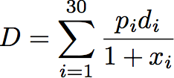
Constraints

The optimal solution is constrained by the following:

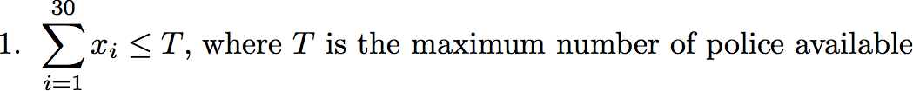

Considering that the Pittsburgh Bureau of Police employs an estimated 1,000 officers, and that the Oakland neighborhood covers approximately 1.29 square kilometers, a value of 100 was chosen for .

The Probability Factor

Background

Riots are known to happen in places that are more populated. An accurate way to gauge the likelihood of a riot in an area is to determine the area’s population density. Once the population densities for an area have been obtained, a probability-generating function is necessary—one that will take in an x coordinate as a parameter. The probability will allow for the determination of whether or not a riot will occur at a given location.
The population of the Oakland area is normally distributed with a mean of 2,174 people per km² and a standard deviation of 758 people per km² (“Oakland, Pennsylvania profile”).

Effective Riot Multiplier

The expected population for an effective riot is the average amount of people residing in an area for an effective riot to take place (Dippity). However, it is contingent upon the location itself. To estimate a population for an effective riot for each location it is necessary to take the expected population and divide it by the median point. Essentially, the average population size of heavily rioted areas was divided by 65, the median x coordinate (the map used will be shown below), which yielded 45.768. This constant multiplied with an x coordinate should give the estimated population for an effective riot in the area represented by that coordinate.

Probability

The distribution then estimates the probability that the estimated population is the population for that area.

Data

Mean | St.dev
2174 | 758
x coord. | Z value | Probability
34 | -0.81516 | 0.207492
40 | -0.45288 | 0.325319
42 | -0.33212 | 0.369901
46 | -0.0906 | 0.463907
46 | -0.0906 | 0.463907
49 | 0.090544 | 0.536072
50 | 0.150923 | 0.559982
54 | 0.392443 | 0.652635
55 | 0.452823 | 0.674662
51 | 0.211303 | 0.583675
59 | 0.694343 | 0.756266
59 | 0.694343 | 0.756266
63 | 0.935863 | 0.825328
62 | 0.875483 | 0.809344
61 | 0.815103 | 0.792493
65 | 1.056623 | 0.854658
66 | 1.117003 | 0.868003
70 | 1.358522 | 0.912851
66 | 1.117003 | 0.868003
72 | 1.479282 | 0.930468
74 | 1.600042 | 0.945205
76 | 1.720802 | 0.957357
80 | 1.962322 | 0.975137
81 | 2.022702 | 0.978448
86 | 2.324602 | 0.989953
86 | 2.324602 | 0.989953
80 | 1.962322 | 0.975137
94 | 2.807641 | 0.997505

Maximum-Damage Coefficients (MDC’s)

The estimation of Maximum-Damage Coefficients (MDCs) presented numerous challenges. These challenges included what damage units to use and how to evaluate expected damage at a large number of potential riot locations. The following discusses how these problems were dealt with and outlines the method used in assigning MDCs.

Recall from earlier

“The MDC is a constant assigned to a given potential riot location that defines the damage at said location given that a riot will occur there with 100% probability and that there are zero police assigned there. Thus, at each location, if the probability of a riot decreases (from 1.0), or the number of assigned police increases (from zero), the expected damage will decrease.”

Area Selection

Area selection presented the first challenge. The area taken into consideration was restricted to the Oakland neighborhood. The reason for this selection is primarily for simplicity, but also creates a better situation for damage estimation (more on this will be explained later). The specific boundaries of the area under consideration are Craft Avenue to the west, Morewood Avenue to the east, Center Avenue to the north, and Bates Street to the south. The proposed area is outlined by heavy black lines in the map shown below.
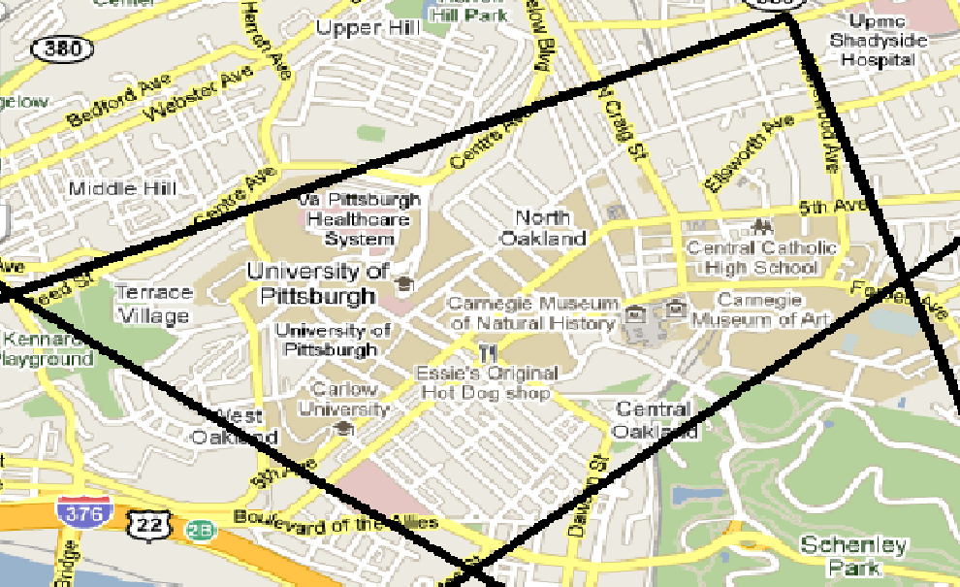

Damage Estimation

The next consideration was how to estimate the damage at numerous potential riot locations. Ideally, independent assignment of MDCs would be made at a large number of potential riot locations. Unfortunately, this becomes quite expensive, especially when considering a potential police location on every intersection in Oakland (a more ideal goal).
Because computational cost is an important aspect of the process, and independent assignment of MDCs had already been ruled out due to its high cost, a new estimation technique became necessary. The new technique needed to be cheap but able to evaluate damage at any potential riot location. It became obvious that damage evaluation at a few key points and interpolation to potential riot locations was more optimal in terms of cost efficiency.
The key points at which MDC assessments are necessary (called “landmarks”) were chosen based on cultural or economic significance. While the landmarks themselves were not considered potential riot locations (the set of landmarks and set of potential riot locations were defined to be disjoint), each would have an effect on the assignment of the MDC at a potential riot location. Determining a realistic relationship between distance from a landmark and expected damage incurred became the next issue.
Considering how a typical riot plays out, it can be assumed that rioters will protest near a landmark, and that damage around a landmark will decrease as distance from a landmark increases. Exponential and linear decay were considered reasonable options for the modeling of this phenomenon. However, the assumptions under exponential decay were more appropriate for modeling riot damage. Linear decay would give negative contributions to a MDC for large distances from a landmark, whereas exponential decay will yield positive results, eventually becoming negligible at large distances. Under exponential decay, each landmark requires an initial value (the MDC at the landmark), and a rate of decay. A small rate of decay is chosen to represent a widespread riot (as with the Super Bowl Riots on the University of Pittsburgh campus). A large rate of decay signifies a localized riot (as with the riots outside Phipps conservatory during the G-20).
As stated before, MDCs are to be assessed at a small number of landmarks throughout Oakland. The contribution of each landmark to the MDC at each potential riot location is then calculated using exponential decay as described above. Next, the MDC at a given potential riot location is defined as the sum of the contributions from each landmark on that potential riot location

The landmarks used in the model considered for this report are shown in the chart below.

Landmark | Rate of Decay
Peterson Events Center | 1
UPMC Presbyterian | 1
The Original Hot Dog Shoppe | 5
Soldiers and Sailors Hall | 5
Cathedral of Learning | .1
Carnegie Museum | .5
Phipps Conservatory | 10
Pittsburgh Central Catholic H.S. | 4

*Note: these rates of decay are based on events that occurred during the Super Bowl XLIII and G-20 riots

The final map used in this report is shown below. It includes thirty police points (denoted by black squares). The landmarks are denoted by blue targets. The red lines show the coordinate axis used in calculating distances from police points to landmarks.
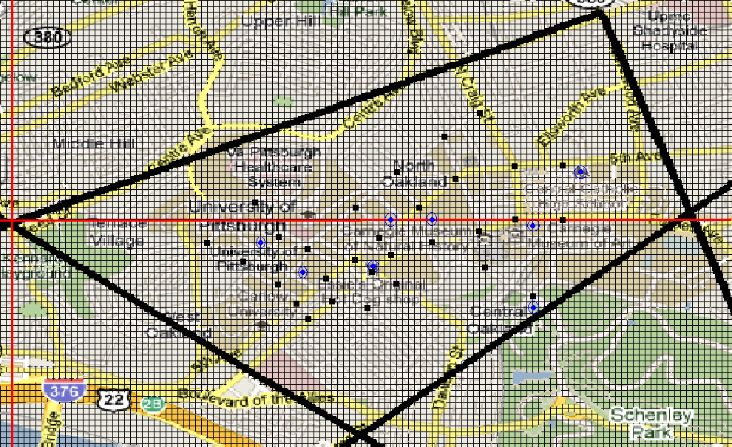

Solving for Optimal Placement

To solve for the optimal placement of police the Branch and Bound algorithm in MATLAB was implemented. The algorithm first solves the “relaxed” problem (RP), for which the optimal X_{i} is a non-negative real number $\text{iÎ left [n right ]\} \{}$ and where $\left[n\right]=\left\{1,2,\text{.}\text{.}\text{.},n\right\}$, with the use of a nonlinear optimization function in MATLAB, FMINCON. The algorithm then branches on the first optimal non-integer X_{i} and bounds using the current best integer solution.

Solving Relaxed Nonlinear Problem using FMINCON

In order to solve the RP, the FMINCON function in MATLAB was used. FMINCON uses an Active-Set algorithm to find the minimum of a function subject to several constraints. It is important to note that FMINCON also uses function and constraint tolerances to determine when to stop, so the solution it returns may not be exact, but approximate.

Branch & Bound Algorithm

The Branch and Bound (B&B) Algorithm solves the optimal placement problem by doing the following:

1. Track a current best integer solution (currAssign) and function value (currOpt). At the start, this is done by setting X₁=X₂=…=X_{n}=0 so that
currOpt = $\sum{p_{i}}d_{i}$.
2. Solve the RP using FMINCON, returning function value rpOpt.
If rpOpt ≥ currOpt then skip steps 3 and 4.

3. Let b = min{i $Î$ [n] | X_{i} is not an integer} and let
RP1: RP with additional constraint $X_{i}≤\left\lfloor X_{i}\right\rfloor$
RP2: RP with additional constraint $X_{i}³\left\lceil X_{i}\right\rceil$

4. Repeat steps 1-4 for RP1 and then for RP2.

In essence, one can assume that FMINCON returns the exact optimum, then B&B will solve the optimal placement problem by exploring all feasible and worthwhile cases for the solution.

Results and Analysis

Several results to the optimal placement problem were obtained. The results differ in the methods and tolerances used. To obtain a rough idea of the optimal placement, solutions to the RP were found using both the FMINCON function and the method of Lagrange multipliers. For FMINCON, several function and constraint tolerances were tested, all of which strangely produced different nearly integer solutions. In the table below, only the results from the lowest tolerance (E-100) are shown. This motivated a calculation of the exact optimum using the method of Lagrange multipliers for which the restriction on X_{i} being non-negative $\text{iÎ left [n right ]\} \{}$ was eased (note X₁ <0 below). The drastic differences of the solutions and their values below suggest that the Active-set algorithm is neither accurate nor efficient when given a highly unconstrained problem. This is justified by observing the results from the branch and bound function that return solutions with a smaller expected damage despite given larger tolerances (E-20, E-30).

 | X coordinate | Optimal Non-integer Placement |  | Optimal Placement
Method |  | Lagrange | FMINCON | Branch and Bound
 | 34 | -0.2718 | 0 | 0 | 0
 | 40 | 0.3160 | 0 | 0 | 0
 | 42 | 0.4595 | 0 | 0 | 0
 | 46 | 1.2821 | 0 | 0 | 1
 | 46 | 0.7969 | 0 | 0 | 0
 | 49 | 1.0558 | 0 | 0 | 1
 | 50 | 1.6209 | 0 | 0 | 2
 | 54 | 2.1143 | 0 | 0 | 4
 | 55 | 1.9453 | 0 | 0 | 3
 | 51 | 1.1339 | 0 | 0 | 5
 | 59 | 3.8586 | 0 | 0 | 4
 | 59 | 3.4824 | 0 | 0 | 4
 | 63 | 5.0967 | 0 | 2 | 4
 | 62 | 3.9512 | 0 | 0 | 4
 | 61 | 2.7876 | 0 | 0 | 4
 | 65 | 5.2875 | 0 | 27 | 0
 | 66 | 4.3698 | 0 | 0 | 2
 | 70 | 7.9449 | 25 | 2 | 6
 | 66 | 5.0939 | 0 | 9 | 4
 | 72 | 7.5173 | 50 | 4 | 4
 | 74 | 4.1697 | 0 | 0 | 4
 | 76 | 6.0529 | 0 | 27 | 4
 | 80 | 6.0943 | 0 | 29 | 6
 | 81 | 4.8660 | 0 | 0 | 4
 | 86 | 5.3430 | 25 | 0 | 8
 | 86 | 3.7018 | 0 | 0 | 4
 | 80 | 2.9775 | 0 | 0 | 5
 | 94 | 3.1695 | 0 | 0 | 5
 | 94 | 2.3145 | 0 | 0 | 4
 | 89 | 2.4682 | 0 | 0 | 4
 | Expected Damage | 1.01E+06 | 4.01E+06 | 3.10E+06 | 1.35E+06
 | Tolerances |  | E-100 | E-20 | E-30
 | CPU Time (s) |  |  | 1596.9 | 19648.82

Improvements to the Model

The following are improvements to the model that are worth implementing:

- Consider a significantly larger set of potential riot locations that spans a larger area.

A greater number of potential riot locations would allow more accurate placement of police within the confines of the model. Widening the area to which the model applies (e.g., to the entire city of Pittsburgh) would simply make the results more valuable.

- Improve the validity of the Maximum-Damage Coefficients and the riot probability distribution.

The current distribution makes too strong an assumption—that the probability of a riot depends only on Oakland’s population densities as they relate to an east- west horizontal axis. An improved probability distribution would take into account a potential riot location’s position on the vertical axis in addition to its horizontal coordinate.
While convenient, the assumptions used in the determination of Maximum-Damage Coefficients are very strong. Interpolating MDCs based on those of landmarks, as the method dictates now, discounts the inherent value of the potential riot locations themselves. Realistically, one cannot assume that the “value” of a location depends solely on its proximity to a site of cultural or economical significance. A better, but less cost-effective alternative is to independently assess the expected damage at each potential riot location assuming a constant riot size and no police protection. Additionally, the landmarks should be added to the set of potential riot locations—the current model uses them only to determine MDCs.

- Employ a more realistic objective function.

Assuming that the improved model incorporates a much larger set of potential riot locations, police “assistance” is a reasonable assumption. That is, one can assume police are mobile and can assist the police at adjacent potential riot locations. Thus, the expected damage at any potential riot location would be reduced by the number of police at all adjacent locations. (“Adjacent” here is defined as one distance unit away along the horizontal or vertical axis.) The following objective function incorporates this assumption:

represents an indicator function. Define P as the set of all potential riot locations, this time defined by all feasible (x,y) pairs within a square area. Also, superimpose the first quadrant of the Cartesian coordinate system onto the target area, where n is the maximum x and y coordinate.
Works Referenced
Briem, Christopher. City of Pittsburgh Population Density by Census Block - 2000. 2000. Raw data. University of Pittsburgh University Center for Social and Urban Research, Pittsburgh, PA.
"Oakland, Pennsylvania (PA 16101) profile: population, maps, real estate, averages, homes, statistics, relocation, travel, jobs, hospitals, schools, crime, moving, houses, sex offenders, news." Stats about all US cities. Web. 11 Nov. 2009. <http://www.city-data.com/city/Oakland-Pennsylvania.html>.
"Pittsburgh Riots." Dipity. Web. Fall 2009. <http://www.dipity.com/timeline/Pittsburgh-Riots>.
"Pittsburgh Riots." Google News Timeline. Web. 11 Nov. 2009. <http://newstimeline.googlelabs.com/>.

