Analysis of Inventory Optimization Strategies for Alcoholic Beverages in a New Orleans Bar

Kelly Carter, Patricia Rupinen, Peter Satagaj

Introduction
The bar in question, hereafter referred to as “NOBrews” since they requested anonymity, currently employs the policy of reordering products when and only when their inventory runs out. They store up to the maximum given current space constraints. NOBrews has noticed that their profit is low, and have requested an analysis of their ordering scheme in an attempt to rectify the situation. We researched the optimal quantity of each product to order and how often to place orders as well as calculating the probability of a stock-out in an effort to decrease cost and therefore increase profit at NOBrews.
As seen in Appendix A, data recorded by a new system provides the amount of each product sold in October of this year. Several different types of alcoholic beverages are sold, each with their own unit of measure. Beer is sold in draft from kegs as well as in bottles, wine is sold by the bottle and by the glass, and spirits are bought by the bottle and sold in drinks (either shots or mixed drinks). Our inventory analysis will be performed separately by the product’s unit type.
Demand is the number of units of a product sold in a week, which is found from the amount sold in October (using an average). NOBrews has 130-150 square feet for bottles and a separate area to store up to 20 kegs. In the bottle storage area there is room for 600 ± 200 bottles of beer, 300 ± 100 bottles of alcohol (wine and spirits), and 20 for nonalcoholic mixers. We have the option of moving any part of the 20 square feet of nonalcoholic mixers to the restaurant kitchen, which is why storage space is variable (between 130 and 150 square feet). Currently, 130 square feet is used for bottled beer, wine, and spirits. We use the estimate that one square foot of storage holds 4 bottles of alcohol (liquor/wine) or 9 bottles of beer.
We assume that weekly demand follows a normal distribution. Mean demand is calculated from the data as well as low, mid, and high estimations (Appendix B). It is estimated that 75% of the total revenue from each product listed is shipping cost and 25% is profit. We assume one bottle of wine contains 3-4 glasses (drinks), one bottle of liquor makes 14 drinks, and a keg yields about 100 drafts of beer (100 drinks).

Inventory Optimization
For this project we have decided to use a modified Wilson’s lot size equation. This equation chooses the optimal order amount and time to minimize that average total cost over an infinite time. The original equation is:
$$K=\frac{A}{T}+\frac{I*Q}{2} (1)$$
In this equation K stands for the optimal average total cost; A stands for the shipping cost for the item; T stands for the optimal time period between orders; I stands for the inventory cost per item which in this case is proportional to size of the item; Q is the number of items ordered. For this equation we also assume that demand is a constant λ and that Q= λ*T. Now for our problem we have a few more constraints that have to be accounted for and a few assumptions to make. First we must recognize that we have to optimize more than one product. Second we assume that the demands of these items are independent. We do this because we are limited by the data that we have which is not enough to give us any idea of the correlation between demands. We are also told that there is no discount for shipping items together. At this stage we can move to slightly better model. It is easy to see that each items cost function is independent of all other items. This is because shipping cost doesn’t change with relation to what gets ordered together and demand is only a function of the item in. So from this we get that the optimal cost can be found by taking the sum of each items individual optimal cost:
$$K=\sum_{i=1}^{n}{\frac{A_{i}}{T_{i}}+\frac{I_{i}*Q_{i}}{2}} (2)$$
Where there are n items and each item also has its own demand λ_{i}. Unfortunately we still have more constraints which we have to fit. Namely we have a size constraint. We could only fit up to 150 square feet for the bottles and 20 kegs for the drafts. Because there are two different size constraints we split up the model into two one for the bottles and one for the kegs which can be added together later. So the equation is the same as above but now it is subject to the constraint:
$$\sum_{i=1}^{n}{f_{i}*Q_{i}=F (3)}$$
Where f_{i} are the weights for bottles they are the size of the bottles e.g. beer=1/9 sq. ft., alcohol=.25 sq. ft. for kegs they are all one. F is the total space so 150 sq. ft. for the bottles and 20 for draft. Now we have the basic outline of our model before we add in the final constraints we solve for optimal Q_{i}’s. To do this we first ignore the constraint because if the optimal solution happens to take up less space than what is available then we do not need to change anything. To find a Q_{i} we are just finding the optimal amount for a single unit Wilson’s lot size problem. We know from class that the solution for this is:
$$Q_{i}=\sqrt{\frac{2*A_{i}*λ_{i}}{I_{i}}} (4)$$
When we solve this we found that in both cases (bottles and draft) went over the space constraint. The following few sentences are from the notes on inventory optimization on the class website. We are now attempting to minimize K subject to the constraint (3) using the Lagrange Multiplier Technique. This would state that there exists θ such that optimum for minimizing K subject to constraint (3) is:
$$\frac{∂K}{∂Q_{j}}=θ\frac{∂F}{∂Q_{j}} (5)$$
Differentiating we get
$$-\frac{λ_{j}*A_{j}}{Q_{j}^{2}}+\frac{I_{j}}{2}= θ*f_{j} (6)$$
Or
$$Q_{j}=\sqrt{\frac{2*λ_{j}A_{j}}{I_{j}-2*θ*f_{j}}} (7)$$
Now we solve for $θ$ using:
$$\sum_{j}{f_{j}*\sqrt{\frac{2*λ_{j}A_{j}}{I_{j}-2*θ*f_{j}}}=F (8)}$$
Which can easily be solved for in excel. The solution it gives us though is not in discrete units. We can only order a discrete number of kegs or bottles. Also we can only order on a discrete number of weeks greater than or equal to one. To do this I came up with another problem I could maximize in Excel:
$$Minimize \sum_{i=1}^{n}{\frac{A_{i}}{T_{i}}+\frac{I_{i}*\left\lceil λ_{i}*T_{i}\right\rceil }{2}}$$
Subject to
$$\sum_{i=1}^{n}{f_{i}*\left\lceil λ_{i}*T_{i}\right\rceil ≤150}$$
$$T_{i}≥1 ∀i where all T_{i}^{'}s are integer$$
Excel only allows the parameter’s being modified to be integer only so using the ceiling of Q_{i} = λ_{i} * T_{i} is my way of forcing to amount to be the integer (erring on the side of having too much in stock because demand uncertainty trumps cost). In Excel instead of having a constraint for each of the T_{i}’s I just have a constraint that is the sum over i of the min(1,T_{i})=n, this is the same thing as above but it is easier to code into solver.
Appendix C lists the optimal amounts for each product and how often they should be ordered (in weeks between purchases). Also included is the cost for each product, which can be totaled to $1,360.42 for everything as listed.

Opportunity Cost Analysis
A stock-out is when inventory of a product runs out before demand does. Even though we now know the optimal order strategy for each product, there is still a chance that demand could fluctuate enough for stock-outs to occur. Insuring that the incidences of stock-outs are minimized is extremely important as they can be very detrimental to small businesses because of the opportunity costs created. We would like to guarantee that products have no more than a 5% chance of a stock-out. Analysis will be performed using a modified PERT method, which is commonly used to predict completion times of supply chains in product management. It is used to calculate the probability that the demand for a given time period (weeks between orders) will be higher than the inventory available for that time period, in which a stock-out would occur.
Each item’s low, mid, and high demand for the week are based on the estimated average demand per week. Typically we would apply a ceiling function to the values because purchasing fractions of products is unreasonable. However, because the demand values are so low, the mathematical problems encountered with the ceiling function forced us to keep the unrounded values.
Using the weekly low, mid, and high demand values for each product, we find a mean and a variance for the normal distribution model we use as that product’s weekly demand.
Mean = (low + 4 * mean + high) / 6 (9)
Variance = (high - low)^2 / 36 (10)
After these values are found for each product, we use the NORMDIST function in Excel to find the probability that the demand is above the inventory, resulting in a stock-out. The inventory analysis earlier produced results for how many units of a product were purchased for how many weeks. This information was used to calculate how much stock was available. Formulating the probability of demand being above stock was done by subtracting the probability that demand was at or below stock levels from one. We found that about 35% of NOBrews’ products had above a 5% probability of a stock-out, but none were above a 15% probability.
Appendix D shows the calculations for finding the probability of a stock-out as well as the final results for each product. Highlighted cells are products with high probabilities of stocking out (above 5% and above 10%).
Conclusion
NOBrews has a very low demand, which is contributing to their low profit. However, there are areas of their inventory procedures which could help in decreasing costs. If they shift to an ordering scheme as we have described in our analysis, they will be much better off than ordering multiple times a week, and ordering only what is out of stock. This would require that the nonalcoholic “mixers” be moved to the restaurant section because the extra space is necessary to hold the suggested inventory (142 square feet total and 16 kegs). Because products with low demand are unprofitable and take up space which could be used to hold “padding” inventory of highly demanded products, we recommend that NOBrews discontinues them completely. Products with less than five units per month include Chartereuse, Johnny Red, Patron Citron, Pool, Smokes, Ultimat, Bacardi Gold, Bookers, Courvoiseier, Cruz Mango, Evan, Evan Honey, Glenlevit, Patron Café, Pimms, Pyrat, Rye, Sambuca, Stoli Straw, and White Zin. Many of these products are higher-end alcohols, and because of the location of the bar, and the market they sell to, it is unsurprising that the demand is low. We recommend discontinuing at least the lowest demanded products if not all listed above.
Highly demanded products which will require extra “safety” inventory are Bud, Bud Lite, Coors Lite, High Life, Miller Lite, PBR, Crown, Kettle, Patron, Well Gin, Pinot Grigio, and kegs of Arn Weed. These are the most common alcohols in the area, and are low to mid-shelf quality. Because they are so popular, fluctuations could create large stock-outs for the bar, so we suggest they keep extra inventory to reduce this risk.
NOBrews needs to focus on either common, lower-shelf alcohols, or only high-end. Data received from the bar shows that their demand is mostly the first, so we suggest they focus on this type of stock. We believe these recommendations will help NOBrews decrease cost, increase profit, and therefore remain open and profitable.

Appendix A: Raw Data
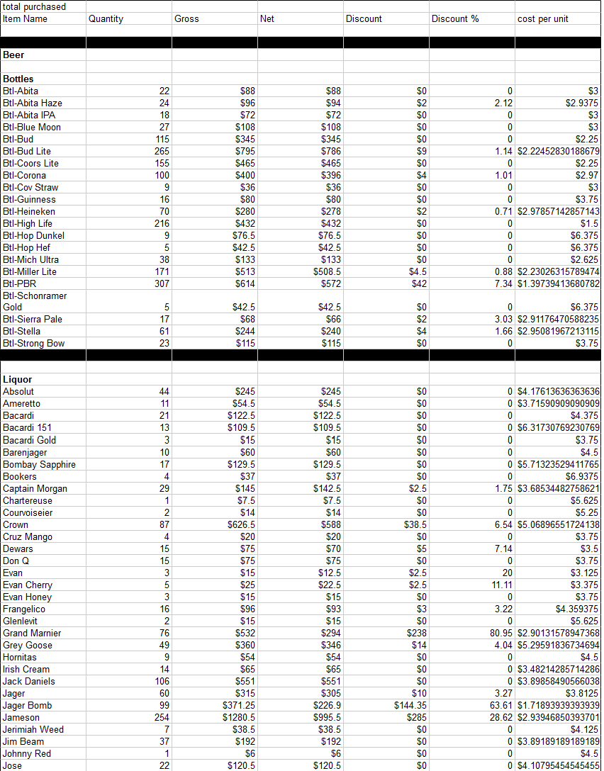
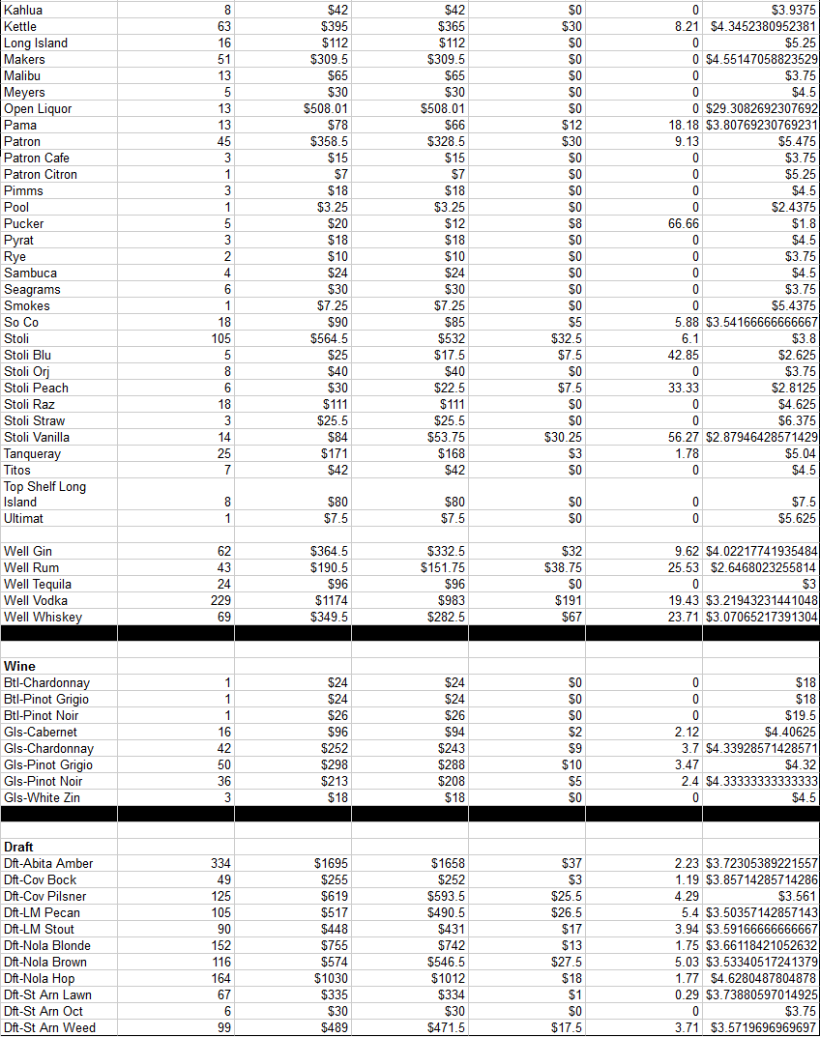

Appendix B: Demand values with mid, high, and low estimations

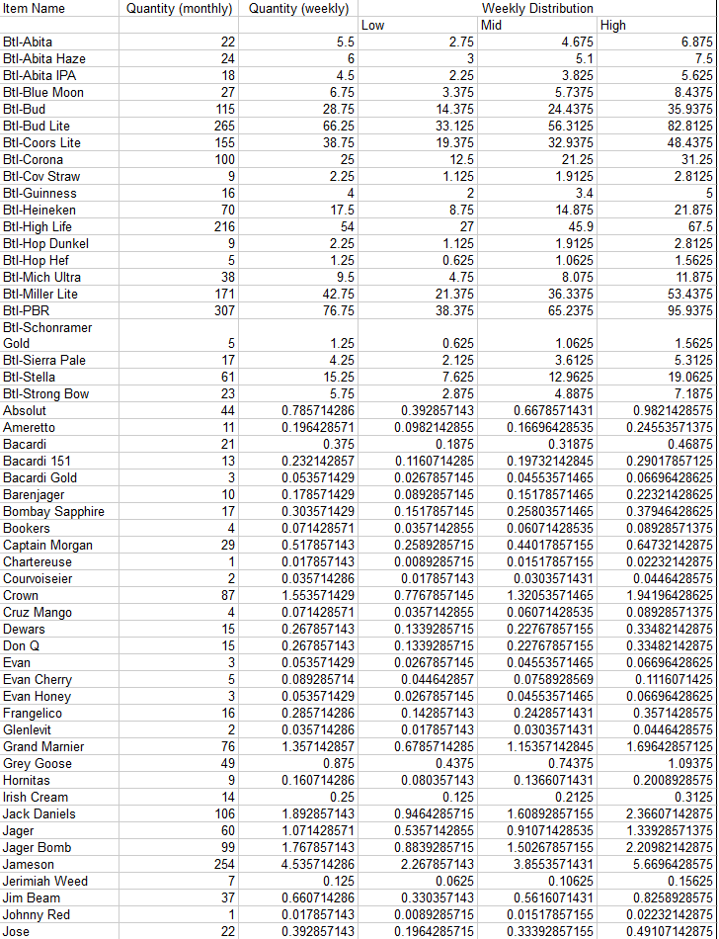
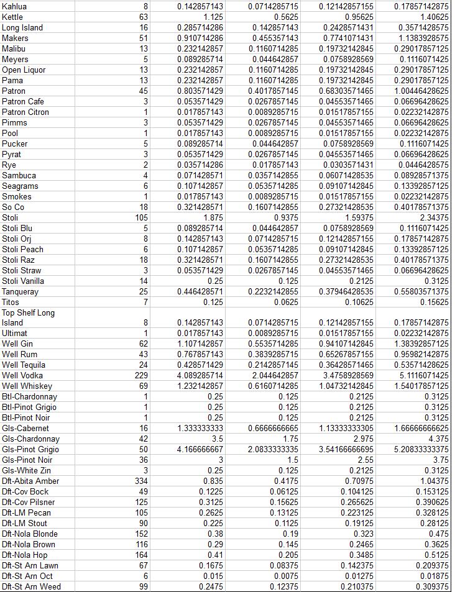

Appendix C: Inventory Optimization Results

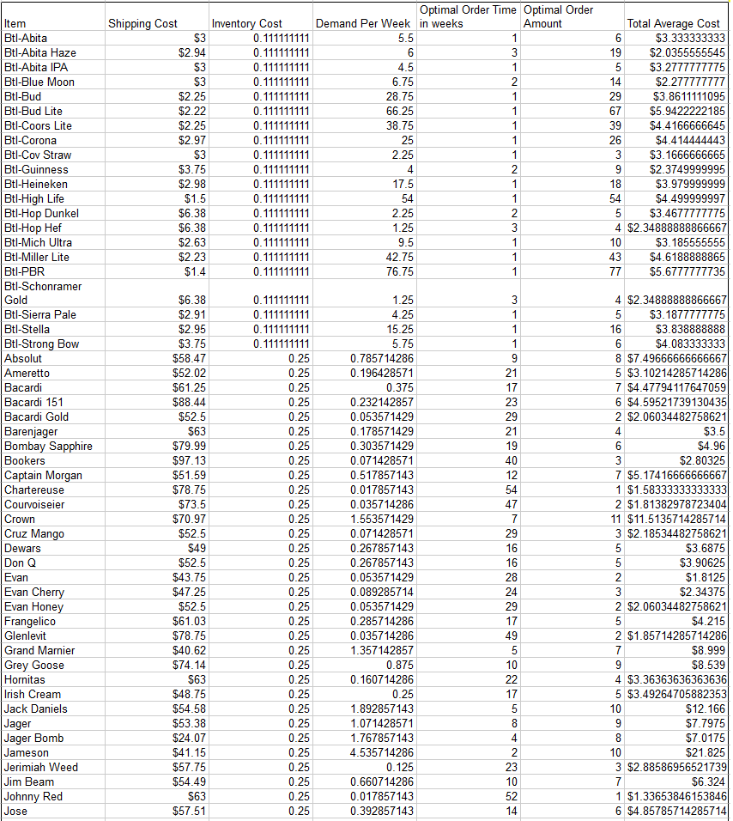
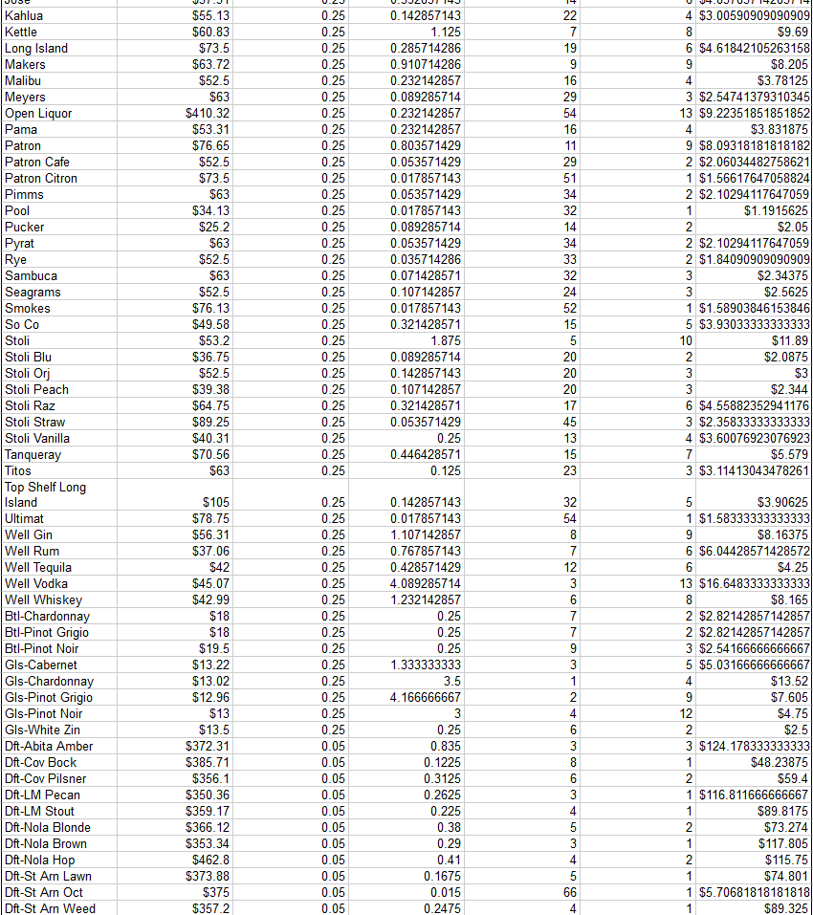

Appendix D: Probability of a Stock-out

